

Bath and North East Somerset

**Schedule of**

**Core Strategy Amendments**

**November 2013**



The Core Strategy is the principal planning document in the district to 2029. The strategy is currently being examined by a Government Planning Inspector.

In order to address the Inspector’s concerns around housing delivery the Council is suggesting amendments to the Core Strategy to allocate strategic sites for development on the edge of Bath, Keynsham and at Whitchurch village and is consulting these and a number of other changes.

This schedule lists the latest amendments to the Core Strategy and comments are invited on the suggested and rejected Strategic Site allocations and other changes.

This consultation is your chance to make your views known to the Planning Inspector to inform the next stage of the Examination in early 2014.

All comments received between 11th November and 20th December 2013 on these amendments will be forwarded to the Inspector for his consideration.

**Preface**

***Background***

Earlier this year the Council consulted widely on proposed changes to the Core Strategy including the identification of broad strategic locations where land should be removed from the Green Belt for development. The identification and allocation of specific development sites and the definition of a revised detailed Green Belt boundary in these locations was to be undertaken through the Placemaking Plan.

The Core Strategy Examination has now resumed. Since the hearing on 17th September 2013, at which the geographic scope of the Strategic Housing Market Assessment (SHMA) was discussed, the Inspector has raised a number of other concerns primarily regarding Green Belt matters as expressed in his note ID/40. More specifically the Inspector is concerned that the current process of identifying broad locations in the Core Strategy and allocating specific sites in the Placemaking Plan will mean that housing in these areas will not be delivered quickly enough. So in order to deliver housing quickly enough the sites need to be allocated for development, land removed from the Green Belt and a revised detailed Green Belt boundary defined in the Core Strategy.

In order to address the Inspector’s concerns around housing delivery the Council is suggesting amendments to the Core Strategy to allocate strategic sites for development and is consulting on these and a number of other changes. These amendments do not relate to the principle of releasing land in these locations but to the suggested strategic sites and Green Belt boundaries along with the placemaking principles relating to their development. It was previously envisaged that this work would be undertaken in the Placemaking Plan and not the Core Strategy.

Sites are being suggested for allocation in five locations in the Green Belt currently referred to in the Core Strategy:

* Odd Down/South Stoke
* Weston
* East Keynsham
* South West Keynsham
* Whitchurch

A significant amount of evidence base work has been done to inform site allocations and much of this was published on 13th September 2013 as part of the Examination process. This and any additional evidence can be found on the Council’s website [www.bathnes.gov.uk/corestrategy](http://www.bathnes.gov.uk/corestrategy)

Following public consultation on these amendments all representations received will be analysed and sent to the Inspector for his consideration. The Examination hearings to discuss the Green Belt sites will be held in early in 2014. The dates for such hearings will be published on the Council’s website at: <http://www.bathnes.gov.uk/services/planning-and-building-control/planning-policy/core-strategy-examination#two>

***Consultation on the Core Strategy Amendments - November 2013***

The Inspector has asked for comments on the Core Strategy amendments so that he has a full range of views when examining the soundness of the Core Strategy. Concept Diagrams for the strategic site allocations are set out at **Annex 1** and changes to the Policies Map[1], at **Annex 2**. Key consequential changes to other parts of the Core Strategy arising from the strategic site allocations are also included in this schedule. Other minor consequential changes will be picked up when the Inspector advises on the Main Modifications to the Core Strategy at a later stage. Commentsare also invited on the **rejected Strategic Site allocations** - see **Annex 3** for maps.Information on rejected sites can be found in the Sustainability Appraisals Addendum Report and the Council’s note BNES/51. These and other amendments the Inspector is asking us to consult on will be tested through the Examination process. If you wish to submit comments you are strongly encouraged to use the representation form and to submit it by email to [planning_policy@bathnes.gov.uk](mailto:planning_policy@bathnes.gov.uk). All comments received between **11th November and 20th December 2013** on these Suggested Amendments will be forwarded to the Inspector for his consideration.

Please note that deletions to existing text are shown as ~~strike through~~ and new or additional text is shown as underlined. The amendments are expressed as changes to the Submitted Core Strategy. In order to avoid confusion, text relating to the allocations of the strategic sites replaces the previously Proposed Changes from March 2013 relating to the broad locations.

| **Change Ref** | **Page No in Draft Core Strategy** | **Plan Ref** | **Core Strategy Amendments (November 2013)** | **Previous change Ref** | **Reason for change** |
| --- | --- | --- | --- | --- | --- |
| **CSA1** | 17 | Para 1.16 | The principal purpose of the Core Strategy is to set out clearly the spatial distribution of development within the District ~~based on~~ in order to deliver~~ing~~ the vision and strategic objectives outlined above. It ~~then~~ provides an overarching spatial strategy for the District ~~followed by more~~ as well as specific policy-frameworks for Bath, Keynsham, the Somer Valley and the Rural Areas. Where land is to be released from the Green Belt, strategic sites are allocated. ~~There are also a number of~~ The Core Strategy also includes generic core policies applicable across the district as set out in section 6. ~~In setting out~~ The policy approach ~~we have taken~~ takes account of national policy guidance, the results of key studies ~~and other relevant evidence~~ as well as the issues identified through the consultations and public engagement on the Core Strategy ~~launch document and ongoing engagement~~ with stakeholders and local communities. | - | Clarification and arising from response to ID/40. |
| **CSA2** | 18 | Para 1.18 | **~~1d District Wide Spatial Strategy~~**  **Development of the Spatial Strategy**  **1.18** ~~Proposals to abolish the Regional Spatial Strategy (RSS) has necessitated a move away from regionally imposed growth targets and the establishment of growth requirements in accordance with the NPPF and in response to local circumstances.~~  Formulation of ~~this~~ the ~~overarching~~ policy framework for the District has been guided by the NPPF and entailed analysis of ~~up-to-date~~ evidence, formulation of options to meet the objectives, engaging with local communities, testing ~~these~~ options through the sustainability appraisal and assessing deliverability. Account has been taken of the District's functional relationship with neighbouring authorities. ~~The process of developing a spatial strategy for B&NES has entailed the assessments set out below.~~ Please note the evidence base supporting the Core Strategy is listed and is available on the Council's website at [www.bathnes.gov.uk/corestrategy](http://www.bathnes.gov.uk/corestrategy) or on request. | - | Clarification and updating. |
| **CSA3** | - | Paras 1.19a-c | **1.19a** ***Development Needs:*** The Council has undertaken an assessment of the needs of development within the District during the plan-period. This includes assessing the space needed for economic growth, housing, retail provision and social needs. This takes account of the Council's objective of promotion of a higher value economy rather than only volume growth. The Council has prepared prepare a Strategic Housing Market Assessment (SHMA) to help assess its full objectively assessed housing needs in the housing market area over the plan period up to 2029.  **~~1.24~~** 1.19b In terms of affordable housing need, Bath has one of the widest house price to earnings ratios outside of London but affordability varies across the District. The Council has therefore undertaken a viability study to inform a new policy framework on securing affordable housing through the planning system.  ***1.19b Development land supply*:** A detailed, assessment has been undertaken of the capacity of the District's settlements for delivery of new housing in the SHLAA, jobs and community facilities. This has included identifying suitable and deliverable development sites, understanding the environmental constraints including potential flood risk, assessing the appropriate mix of uses and densities and ensuring the necessary infrastructure is in place or can be secured to deliver mixed and balanced communities. It also looked at the opportunities to re-use empty homes and under-used properties. ~~Part of this analysis is set out in the Strategic Housing Land Availability Assessment (SHLAA).~~ | - | Clarification and updating. |
| **CSA4** | 19 | Para 1.23 | **~~1.23~~ *~~Development need~~*~~:~~** ~~The Council has also undertaken assessments of development need within the district during the plan-period. This includes assessing the space needed for economic growth, housing, retail provision and social needs. This takes account of the Council's objective of promotion of a higher value economy rather than only volume growth. In terms of housing need, the Council has assessed the post recession likely need requirement for new housing, both market and affordable housing, over the plan period up to 2026 2029 through the B&NES SHMA. This is based on:~~  ~~• Projected population change arising from births over deaths and increasing life expectancy~~  ~~• The likely housing requirement this entails, including rapid decline in household size and increased separation rates~~  ~~• The need for housing generated by economic growth (net migration), taking into account likely future growth rate, productivity changes and sectoral changes,~~  ~~• Provision for non-economically active migrants~~  ~~• Under provision in previous years~~  ~~• Affordable housing need~~ | - | Consequential change. |
| **CSA5** | 19 | Para 1.24 | **~~1.24~~** ~~In terms of affordable housing need, Bath has one of the widest house price to earnings ratios outside of London but affordability varies across the district. The Council has therefore undertaken a viability study to inform a new policy framework on securing affordable housing through the planning system.~~ | - | Consequential change. |
| **CSA6** | - | Paras 1.26 a-d | **1.26*****Scale and location of growth:***  **1.26a** The objectively assessed need for housing and the requirements of the plan are 8,727 dwellings which includes 5,437 market homes and 3,290 affordable homes (Table 1A below). It is these figures against which the implementation of the plan will be monitored. A five year land supply of specific deliverable sites will be maintained against this disaggregated District-wide requirement for both market and affordable housing. In order to meet the economic growth aspirations, the strategy also needs to enable the delivery of around 10,300 new jobs.  Table 1A – Housing Requirements   |  |  |  |  | | --- | --- | --- | --- | |  | Local Plan Backlog 1996-2011 | Newly Arising Need 2011-2029 | Total Housing Requirement | | Market housing | 757 | 4,680 | 5,437 | | Affordable housing | 410 | 2,880 | 3,290 | | Total housing | 1,167 | 7,560 | 8,727 |   **1.26b** The supply of market and total housing that will be delivered (See Table 1B) is significantly greater than objectively assessed requirements. This is because the supply of market housing has been boosted to enable the delivery of the total affordable housing requirement.  Table 1B – Housing Land Supply   |  |  | | --- | --- | |  | Total Housing Delivery | | Market housing | 9,646 | | Affordable housing | 3,290 | | Total housing | 12,956 |   **1.26c** This does not mean that all 12,956 homes are needed to deliver all 3,290 affordable homes. Much of the supply of market housing is on sites that will not yield any affordable housing. This reinforces the justification for identifying a 5 year land supply of specific deliverable sites against the disaggregated requirements for market and affordable housing.    1.26d ~~The Core Strategy makes provision for around 12,700 new homes and around 10,170~~~~new jobs.~~  The spatial distribution of housing across the District is set out in the Key Diagram and summarised in Table 1B below. The strategy is to locate new development in the most sustainable locations and the priority is to steer growth to brownfield land in urban areas of Bath, Keynsham and the larger settlements in the Somer Valley. However, in order to make provision for housing and employment needs and to fulfil the objectives of the Core Strategy, some greenfield land is also required. In some instances this entails the release of land from the Green Belt because these are the most sustainable locations. The identification of land for development has sought to minimise the impact on the environment and the harm to the Green Belt ~~and~~ ~~take~~ as well as taking account of infrastructure requirements. The Council has therefore sought to make provision for level of development likely to be needed but it is acknowledged that the district's environmental quality provides a challenge for accommodating new development The broad spatial principles are summarised below and elaborated in the place-based chapters 2-5.  Table 1C – spatial distribution of housing   |  |  |  |  | | --- | --- | --- | --- | |  | **Market housing** | **Affordable housing** | **Total**  **housing** | | Bath | 5,130 | 1,890 | 7,020 | | Keynsham | 1,580 | 570 | 2,150 | | Somer Valley | 1,870 | 600 | 2,470 | | Rural Areas | 930 | 190 | 1,120 | | Whitchurch Green Belt | 140 | 60 | 200 | | Total | 9,650 | 3,310 | 12,960 | | - | Amendments reflect evidence base. |
| **CSA7** | 19 | Para 1.27 | ***Bath*,** ~~as~~ is the District’s the economic driver ~~in the district is~~ and the primary focus for new development. It is also an important sub-regional economic centre. Significant provision is made within Bath for economic growth, particularly modern employment space to meet the changing needs of the economy and take advantage of Bath's competitive position. The Council's policy of 'smart' growth promotes higher value sectors rather than only volume growth. Key areas of change within the city are along the riverside, especially in the western corridor in the Enterprise Area. In order to meet development needs, land also needs to be released from the Green Belt. The Council has undertaken a careful assessment of the options and has identified locations which cause the least harm to the City’s highly sensitive environment and seeks to minimise scale of the impact. Land ~~will~~ is therefore ~~be~~ released from the Green Belt at Weston and Odd Down and allocated for development. | - | Amendment arising from response to ID/40 and for clarification. |
| **CSA8** | 19 | Para 1.28 | ***Keynsham*** currently has a balance between numbers of resident workers and jobs but experiences significant in and out-commuting in light of the mismatch of resident workforce and available jobs. Although the additional homes/jobs provision for Keynsham is roughly equal, the focus will be to generate a range of jobs more suitable to the resident workforce. The key areas of change in Keynsham will be in the town centre and at Somerdale which has significant implications for the future of the town. In addition ~~changes to~~ land is removed from the Green Belt ~~are proposed~~ to the south west and east of the town and allocated for development in order to provide additional employment floor space and housing. However, infrastructure constraints and ~~the~~ national Green Belt objectives limit the level of development that the Town can accommodate. Land is also removed from the Green Belt at East Keynsham and safeguarded for development for beyond the plan period. Development will only be permitted on this land when the necessary transport infrastructure improvements in the A4 corridor have been secured. These changes do not undermine the Core Strategy objective to maintain the town's separate identity. | - | Amendment arising from response to ID/40. |
| **CSA9** | - | Para 1.30A | However, in order to meet development needs during the Plan period, land is ~~will be~~ released from the Green Belt and allocated for development in the Whitchurch area. Whilst not well placed for Bath, the Council’s sustainability appraisal identifies land on the edge of Bristol as being a relatively sustainable location. The scope for development is limited in light of the environmental assets in the area and the infrastructure constraints. The Council will need to work closely with Bristol to ensure the development relates well to Bristol and does not prejudice regeneration proposals for south Bristol. | - | Amendment arising from response to ID/40. |
| **CSA10** | 19 | Para 1.31 | The ***Green Belt*** is shown on the Key Diagram. The development of the spatial strategy has sought to minimise the impact on the Green Belt as far as possible. However, as described above, five strategic changes are ~~required~~ made to the inner Green Belt boundary to release land to meet the need for new development. The new detailed boundary is set out on the Policies Map ~~will be established through the Placemaking Plan~~. The detailed inner and outer boundaries of the Green Belt will also be reviewed in the Placemaking Plan in order to address any anomalies or make other necessary adjustments. Exceptional circumstances will need to be demonstrated through this review process in order for the detailed boundary to be changed. | - | Amendment arising from response to ID/40. |
| **CSA11** | 19 | Para 1.33 | ***Delivery*:** The scale of new homes entails a significant uplift in past rates of delivery from around 380 to over 800 in the first five years and over 600 thereafter for the Plan period ~~around 700 per annum~~ although as set out in the SHLAA, the overall trajectory of provision is determined by the performance of individual locations. The provision of new jobs is dependent on national economic performance and objectives in the Council's Economic Strategy being realised through the interventions outlined in the Council's Regeneration Delivery Plans, in particular the objective for economic growth of ~~10,170~~ 10,300 jobs. There is scope with the spatial strategy to deliver an even greater number of jobs in line with the Economic Strategy through 'smart growth' and Enterprise Area proposals and where this does not unacceptably harm the District's environment. | - | Amendment arising from response to ID/40 and current evidence base. |
| **CSA12** | 19 | Para 1.34 | **~~1.34~~** ~~The need for affordable housing in the district is high and the Core Strategy seeks to maximise the provision within the context of the spatial strategy and deliverability. The overall housing figure has therefore been boosted in order to increase provision of affordable housing. This would provide around 3,000 3,110 affordable homes during the plan period.~~ | - | Amendment arising from response to ID/40. |
| **CSA13** | 20 | Para 1.36 | ***Flexibility:*** The Core strategy recognises the need to be responsive in light of future uncertainty and unforeseen circumstances. The spatial strategy therefore enables the identification of a 5 year land supply with a 20% buffer to reflect previous under delivery. The level of housing being planned for also provides significant flexibility and choice of sites ~~in the event that some sites are delayed in coming forward or growth is greater than anticipated~~. The Council will monitor delivery rates in the plan period which will shape the ~~early~~ first review of the Core Strategy programmed for around 2016 to co-ordinate with the other West of England districts. | - | Amendment arising from response to ID/40. |
| **CSA14** | 20 | Policy DW1 | **POLICY DW1 District-wide spatial Strategy**  The overarching strategy for B&NES is to promote sustainable development by:  1: focussing new housing, jobs and community facilities in Bath, Keynsham, ~~Midsomer Norton and Radstock~~  and the Somer Valley particularly ensuring:  a: there is the necessary modern office space in **Bath** within or adjoining the city centre to enable diversification of the economy whilst maintaining the unique heritage of the City  b: sufficient space is available in **Keynsham** to reposition the town as a more significant business location whilst retaining its separate identity  c: there is deliverable space to enable job growth in the towns and principal villages in the **Somer Valley** to create a thriving and vibrant area which is more self-reliant socially and economically  d: development in **rural areas** is located at settlements with a good range of local facilities and with good access to public transport  2: making provision to ~~for~~ accommodate;   1. a net increase of ~~10,170~~ 10,300 jobs; 2. the objectively assessed requirements for homes, including affordable homes, ~~12,700 homes between~~ for the Plan period (2011 to 2029), as set out in the table below; and ~~of which around 3,110 affordable homes will be delivered through the planning system~~.      |  |  | | --- | --- | |  | Total Housing Requirement | | Market housing | 5,437 | | Affordable housing | 3,290 | | Total housing | 8,727 |  1. an increase in the total housing supply to around 13,000 homes to enable the delivery of the affordable housing requirement.   3: prioritising the use of brownfield opportunities for new development in order to limit the need for development on greenfield sites  4: retaining the general extent of Bristol - Bath Green Belt within B&NES, other than removing land meet the District’s development needs at the following locations identified on the Key Diagram and allocated on the Policies Map:   * Land adjoining Odd Down * Land adjoining Weston * ~~Extension to MoD, Ensleigh~~ * Land adjoining East Keynsham * Land adjoining South West Keynsham * Land at Whitchurch   5: requiring development to be designed in a way that is resilient to the impacts of climate change  6: protecting, conserving and enhancing the district’s nationally and locally important cultural and historic assets  7: protecting and enhancing the district's biodiversity resource including sites, habitats and species of European importance  8: ensuring infrastructure is aligned with new development  9. Reviewing the Core Strategy ~~will be reviewed~~ at around five yearly intervals and when necessary, make changes ~~made~~ to ensure that both:   1. the objectives are being achieved, particularly the delivery of the housing and work space targets set out in Table 9to ensure that there remains a flexible supply of deliverable and developable land; and 2. the Core Strategy is planning for the most appropriate growth targets, particularly housing and work space /jobs.   The first review will be timed to co-ordinate with the review of the West of England Core Strategies in around 2016. |  | Amendments to expression of the housing requirement reflecting evidence base.  Amendment to process of review of Core Strategy to address Inspector’s concerns (Scope of SHMA Examination Hearing on 17th September 2013) |
| **CSA15** | 20 | Table 1 | |  |  | | --- | --- | | **Locational Policies**  The Policy Framework for the location of new development is as follows: | **Core Strategy Policy** | | Bath | Policies B1, B2, B3, B3A, B3B, B3C, B4 | | Keynsham | Policies KE1, KE2, KE3A & B, KE4 | | Midsomer Norton, Westfield & Radstock | Policies SV1, SV2, SV3 | | Paulton, Peasedown St. John, Timsbury, Camerton, Hallatrow, High Littleton, Farrington Gurney | Policy SV1, and RA1 or RA2 | | Bathampton, Batheaston, Bathford, Bishop Sutton, Clutton/Temple Cloud, Compton Martin, East Harptree, Farrington Gurney, Farmborough, Hinton Blewett, Saltford, Camerton, Ubley, West Harptree and Whitchurch | Policy RA1 or RA2 | | Whitchurch | Policy RA5 | | - | Amendments to Table 1 to reflect the change in strategy for Bath, Keynsham and Whitchurch. |
| **CSA16** | 21 | Diagram 4 (Key Diagram) | *Amendments to Diagram 4:*   * *show the general extent of the Green Belt as proposed to be amended and indicate the strategic site locations at Bath, Keynsham and Whitchurch* * *amend the housing and employment figures for Bath, Keynsham, the Somer Valley and the Rural Areas.*   *(see Annex 1, p55)* | SPC31  SPC29 | Consequential changes arising from the need to release land from Green Belt to allow for the allocation of strategic sites to address issues raised in ID/40. |
| **CSA17** | 33 | Diagram 5 | *Amendments to Diagram 5:*   * *indicate the strategic site locations at Odd Down and Weston, Bath*   *(see Annex 1, p56) to follow* | SPC47 | Consequential changes arising from the need to release land from Green Belt to allow for the allocation of strategic sites to address issues raised in ID/40. |
| **CSA18** | 34 | Policy B1(3) | **3. Housing**  (a) Enable the development of about ~~7,000~~ 7,020 new homes, increasing the overall stock of housing from 40,000: to 47,000. The following distribution of housing will be planned for  Large sites in the Central Area and Enterprise Area – ~~3,000~~ 3,300  Large sites in the outer neighbourhoods, including former MoD land and the extension to MoD, Ensleigh – ~~2,000~~ 2,100  Small scale intensification distributed throughout the existing urban area - ~~1,000~~ 1,150  Land adjoining Weston – ~~300~~ 150  Land adjoining Odd Down – 300 | SPC54 | Amendment arising from response to ID/40 and updated information. |
| **CSA19** | 47 | Policy B3 | Policy B3 Strategic Policy for Twerton and Newbridge Riversides  1. Role of Newbridge and Twerton Riversides  (including the Bath Press)  These locations form the western extent of the City of Ideas Enterprise Area   * Newbridge Riverside will functions as Bath's primary location for industrial enterprise, providing about 12 ha of land at Locksbrook Road, Brassmill Lane and the Maltings for a range of activities including advanced manufacturing. There is therefore a presumption in favour of retaining land and premises in the B1,B2 and B8 use class where this remains a viable use of land and is supported by market signals that there is demand for continued occupation that cannot reasonably be accommodated elsewhere. * Twerton Riverside has contracted as an industrial location in recent decades. This area is suitable for a broader range of uses and there is scope to redevelop the area to provide new business (B1a, b and c) premises and housing. The area presents an opportunity to host business that is displaced as a consequence of the residential led development of Western Riverside and the growth of the intensification of the Central Area into BWR East. Whilst Newbridge Riverside will remain the core industrial location, Twerton Riverside can provide additional flexibility. It will therefore necessary to maintain an appropriate level of land in this area for B1c uses alongside office uses and housing. | SPC74 | Responding to issues raised in ID/40.  To clarify that this is a multi-functional industrial area. References to B2 and B8 omitted in error. Land is currently allocated for these uses in the adopted Local Plan.  Originally written as B1a-c (i.e. B1a through to B1c and not excluding B1b). Inspector interpreted as excluding B1b. This was not the case but amendment is made for clarity to avoid misinterpretation by others. |
| **CSA20** | - | Para 2.30A | Development on the edge of Bath  In order to meet the need for additional housing within the District during the Plan period development needs to be provided for in three locations on the edge of Bath on land adjoining Odd Down; Weston; and MoD, Ensleigh, Lansdown. In two of these locations (at Odd Down and Weston) land ~~needs to be~~ is removed from the Green Belt. ~~The Placemaking Plan will identify and allocate the sites for development and, where relevant, will define the revised detailed Green Belt boundary~~ Through Policies B3A and B3B respectively land is allocated for residential led development adjoining Odd Down and Weston and a revised detailed Green Belt boundary is defined. Policies B3A and B3B also outline the place-making principles to be met in delivering development on these sites. The place-making principles are also indicated on concept diagrams for each site. | SPC87 | Amendment to address the Inspector’s concerns over housing delivery (see ID/40) by allocating strategic sites, removing land from the Green Belt and defining a revised detailed boundary through the Core Strategy rather than through the Placemaking Plan. |
| **CSA21** | - | Para 2.30B | National planning policy makes it clear that when altering Green Belt boundaries a long term view needs to be taken to ensure that boundaries endure beyond the plan period. Where necessary this can include plans identifying areas of safeguarded land to meet longer term development needs. At both Weston and Odd Down environmental sensitivity and the need to minimise harm means that there is no scope to identify safeguarded land for the longer term. ~~Policies B3A, B3B and B3C outline the planning requirements for each of the three locations which need to inform identification and allocation of the sites in the Placemaking Plan and delivery of the sites through a planning application.~~ | SPC87 | Amendment to address the Inspector’s concerns over housing delivery (see ID/40) by allocating strategic sites, removing land from the Green Belt and defining a revised detailed boundary through the Core Strategy rather than through the Placemaking Plan. |
| **CSA22** | - | Policy B3A | **Land adjoining Odd Down, Bath**  **Strategic Site Allocation**  Policy B3A  Land is removed from the Green Belt as shown on the *Key Diagram* and *Policies Map* and allocated for residential development and associated infrastructure during the Plan period.  The requirements that need to be met to enable development are set out in the Placemaking Principles, Core Policies and indicated on the *Concept Diagram*. The Placemaking Principles, being site specific, take priority over the Core Policies.  **Placemaking Principles:**   1. Residential led mixed use development (to include 40% affordable housing) of around **300 dwellings**, in the plan period. The site should be developed at an average density of 35-40dph. 2. Preparation of a comprehensive **Masterplan**, through public consultation, reflecting best practice as embodied in ‘By Design’ (or successor guidance), ensuring that it is well integrated with neighbouring areas. 3. Provision of **Green infrastructure** including multifunctional green space (formal, natural and allotments); well integrated Sustainable Urban Drainage Systems and habitat, pedestrian and cycle connectivity within the site and to the surrounding area. 4. Include new **Public Rights of Way** and provide enhanced public access within the site and connecting well to the surrounding area. 5. A **Landscape and Ecological Mitigation Strategy** **and Management Plan** is required, as part of the Masterplan, to ensure satisfactory mitigation and protection to include:   *Ecological Requirements*   * Protection of dark skies to the south and east of the location including zones of no artificial light adjacent to the protected tree belt and other ecological features retained or created within the site and in adjacent grazing lands. Light spill should be limited to no more more than 1 lux (equivalent to a moonlit night) * Retention and cultivation of planting features and off-site habitat including the retention of hedgerows and tree belts, as indicated on the *Concept Diagram* * Safeguard skylark interest * New woodland planting along the southern boundary of the plateau, particularly to the east of Sulis Manor (i) within the site and (ii) off-site within the plateau in order to strengthen bat foraging and flight links with Horsecombe Vale * A recreational strategy to minimise harm to adjacent grazing regimes and habitats   Particular attention is to be given to ensure satisfactory compensation, mitigation and protection of European protected bat species and their habitat, and the protection of Priority Species.  *Landscape Requirements*   * Retention and protection of existing trees and significant hedgerows by inclusion within public open space and enhance hedgerows by provision of additional planting * Protect the tree belt on the southern edge of the site and enhance with additional planting to ensure visual screening of the site from views to the south * Avoid or minimise detrimental impacts on (and provide enhancements to important landscape features and significant views): * the Cotswolds AONB * South Stoke Conservation area and its setting * The character of the Cam Brook valley and Sulis Manor Plateau * The character of South Stoke and Combe Hay Lanes * Midford Road and the Cross Keys junction including maintaining open rural views over the plateau * The Wansdyke Scheduled Ancient Monument * Medium and long distance views such as Upper Twinhoe and Baggridge Hill  1. Development causing substantial harm to designated heritage assets, or non-designated heritage assets of demonstrably equivalent significance, and/or their settings should be avoided. In addition, all opportunities should be taken to avoid or minimise other harm. As part of the Masterplan, the following should be addressed:   *World Heritage Site*   * The Southern boundary of the site should remain undeveloped to limit the visibility of development in wider views. An acceptable southerly extent of development and appropriate building heights will need to be established as part of the Masterplan. * The Easterly extent of development and appropriate Eastern boundary treatment should be established as part of the Masterplan. * Control light pollution to protect the visual screening of the site from views to the south.   *Wansdyke Scheduled Ancient Monument*   * Avoid built development in areas that would cause substantial harm to the Wansdyke. An acceptable northerly extent of development and development heights will need to be established as part of the Masterplan. To mitigate impacts tree planting should be retained as indicated on the *Concept Diagram.* * A Management Plan setting out a strategy for the long-term and effective management of the monument including detailed measures for its positive enhancement will be developed in consultation with English Heritage and form part of any development proposals. This should include a recreational and movement solution which serves the new community and minimises harm to the Scheduled Ancient Monument. * Limit development height and density in more prominent areas, such as higher ground and development edges, in order to avoid the development breaking the skyline in views from the Wansdyke. * Limit lighting column heights to that of the development to minimise vertical features within the view from the Wansdyke.   *South Stoke Conservation Area*   * Limit the height and/or density of development closest to South Stoke Conservation Area to avoid and minimise harm to its setting   *Sulis Manor*   * Incorporate Sulis Manor and garden into development sensitively, retaining the framework of trees, and considering the conversion/retention of the Manor House and/or a low density development  1. In relation to **transport**, the following apply:  * Provide vehicular access, and junction enhancement, to facilitate access to the site from Combe Hay Lane * Interconnect with Sulis Meadows Estate and Sulis Manor, connecting existing roads into the new development. This should include pedestrian and cycle links. * Links to the National Cycle Route 24 and Two Tunnels should be facilitated. * There is a potential vehicle access to the site from South Stoke Lane which would necessitate upgrading the Cross Keys junction. Any access road from South Stoke Lane would need to be sensitively designed to enable the maintenance of an open down landscape in views from Cross Keys and Midford Road. * Provide a sensitively designed and improved pedestrian/cycle link, following the desire line to Cranmore Place/Frome Road to allow access to Threeways School and the Supermarket * Provide a safe and attractive pedestrian/cycle link to the Odd Down Park and Ride from the site. * Ensure sufficient car parking in the vicinity of St Gregory’s School to meet the school’s needs  1. Contributions will be required to facilitate the expansion of St Martin’s Garden **Primary School**. 2. The provision of additional **local employment** will be supported at Manor Farm, through conversion and redevelopment. 3. Retain and/or enhance the **Odd Down Football Club** (Football Pitches, Clubhouse and changing facilities, play area, local market and car park) either: 4. in its current location; or 5. by re-providing the Football Club with an equivalent facility within the area 6. **Sustainable Construction** will be required, with all new housing meeting Code for Sustainable Homes Level 5, or its successor, from 2014. The solar energy potential of sites should be facilitated by design and orientation. Development will be expected to provide sufficient renewable energy generation to reduce carbon dioxide emissions from expected energy use in the buildings by at least 20%. Third party delivery options will be expected to have been considered and in exceptional circumstances Allowable Solutions may be utilised. 7. Localised areas of **land instability** must be either avoided or addressed with appropriate remediation. | SPC88 | Amendment to address the Inspector’s concerns over housing delivery (see ID/40) by allocating strategic sites, removing land from the Green Belt and defining a revised detailed boundary through the Core Strategy rather than through the Placemaking Plan.  This text replaces the previous Policy B3A (proposed change SPC88). |
| **CSA23** | - | New diagram | *Land adjoining Odd Down - Concept Diagram*  *(see Annex 1, p57)* | - | Concept Diagram as referred to in Policy B3A (see above) |
| **CSA24** | - | Policies Map | *Amend the Policies Map to shown the boundary of the strategic site allocation for Land adjoining Odd Down, Bath and the revised Green Belt boundary.*  *(see Annex 2, p65)* | - | Consequential changes arising from the need to release land from Green Belt to allow for the allocation of strategic sites to address issues raised in ID/40. |
| **CSA25** | - | Policy B3B | **Land adjoining Weston, Bath**  **Strategic Site Allocation**  Policy B3B  Land is removed from the Green Belt as shown on the *Key Diagram* and *Policies Map* and allocated for residential development, and associated infrastructure during the Plan period.  The requirements that need to be met to enable development are set out in the Placemaking Principles, Core Policies and indicated on the *Concept Diagram*. The Placemaking Principles, being site specific, take priority over the Core Policies.  **Placemaking Principles:**   1. Residential led mixed use development (to include 40% affordable housing) of around **150 dwellings** in the plan period. The site should be developed at an average density of 35-40dph. 2. Preparation of a comprehensive **Masterplan(s)**, through public consultation, reflecting best practice as embodied in ‘By Design’ (or successor guidance), ensuring that it is well integrated with neighbouring areas. This is likely to include development facing onto Lansdown Lane, and rear gardens of new properties backing onto rear gardens of adjoining properties.   3 Provision of **Green Infrastructure** including multifunctional green space (formal, natural and allotments); habitat connectivity; pedestrian/cycle connectivity with the wider area including towards Weston local centre.  4 **Sustainable Urban Drainage** solutions should be well integrated and should serve the sites needs entirely. They should not prejudice the existing funded DEFRA scheme in the Weston area, which deals with existing flooding and surface water problems. In relation to the land behind Eastfield Avenue, any required flood remediation on the lower slopes could use features such as swales.  5 New **Public Rights of Way** should be provided to enhance public access. This could include a new circular walking route, within the sites and linking them together. The existing public right of way from Greenacres should be improved by redirection through the East of Lansdown Lane site.  6 A **Landscape and Ecological Mitigation Strategy** **and** **Management Plan** is required, as part of a Masterplan, to ensure satisfactory, mitigation and protection, to include:   * Retention and protection of existing trees and significant hedgerows by inclusion within public open space and enhance hedgerows by provision of additional planting * New on/off-site woodland buffers around exposed housing areas, as indicated on the *Concept Diagrams* * Provision of a permanent pond at a suitable location for bats to drink from * A recreational strategy to minimise harm to adjacent grazing regimes and habitats * Minimisation of light spill onto new habitat, retained features and adjacent grazing lands of no more than 1 lux (equivalent to a moonlit night) * Use of new tree planting as a framework throughout the proposed development, with sufficient set back to allow growth of trees * Avoid or minimise detrimental impacts on (and provide enhancements to important landscape features and significant views):   + the Cotswolds AONB, particularly the character of the Cotswolds escarpment and the Lansdown Plateau   + The City of Bath Conservation Area and its setting   + Lansdown Lane and its open rural character   + Long distance views such as Bath City Farm and Alexandra Park   + Beckford’s Tower and Lansdown Cemetery & Prospect View   + The Cotswolds Way at Dean Hill   Particular attention is to be given to ensure satisfactory compensation, mitigation and protection of European protected bat species and their habitat, and the protection of Priority Species.   1. Development causing substantial harm to designated heritage assets, or non-designated heritage assets of demonstrably equivalent significance, and/or their settings should be avoided. In addition, all opportunities should be taken to avoid or minimise other harm. As part of the Masterplan, the following should be addressed:   *World Heritage Site*   * The western part of the West of Lansdown Lane site should remain undeveloped to limit the visibility of development in wider views. An acceptable westerly extent of development and appropriate building heights will need to be established as part of the Masterplan. To mitigate impacts of development, new tree planting on the new boundary edge will be required. * The eastern part of the land behind Eastfield Avenue should remain undeveloped to protect the World Heritage Site setting and Beckford’s Tower. An acceptable easterly extent of development and appropriate building heights will need to be established as part of the Masterplan. To mitigate impacts of development, substantial new tree planting on the north-south break of slope will be required.   *Bath Conservation Area and Listed Buildings*   * + Use high quality design to avoid or minimise harm to the setting of the Bath Conservation Area and Prospect Place   + Limit development height and density in more prominent areas in order to avoid development of high impact areas including those that would break the skyline in views from the Grade I Listed Beckford’s Tower   + Limit lighting column heights to that of the development to minimise vertical features within views from across the valley   8 In relation to **transport** requirements, the following apply:   * + Development should provide good connections to and support existing public transport provision (on Napier Road, Lansdown Lane and Eastfield Avenue)   + Contributions towards measures to reduce vehicle speeds on Lansdown Lane will be required   + The land behind Eastfield Avenue should be accessed from a new vehicle access point from Eastfield Avenue; engineering works will be required to achieve acceptable gradients   + Land either side of Lansdown Lane should have vehicle accesses from Lansdown Lane   + Development adjoining Lansdown should provide a new footway on either frontage   + Land to the East of Lansdown Lane, has a level difference between the site and carriageway and requires engineering works are needed to achieve acceptable gradients   9 Contributions will be required to facilitate the expansion of **primary schools** in the North West Bath Primary School Planning Area.  10 **Sustainable Construction** will be required, with all new housing meeting Code for Sustainable Homes Level 5, or its successor, from 2014. The solar energy potential of sites should be facilitated by design and orientation. Development will be expected to provide sufficient **renewable energy** generation to reduce carbon dioxide emissions from expected energy use in the buildings by at least 20%. Third party delivery options will be expected to have been considered and in exceptional circumstances Allowable Solutions may be utilised.  11 Avoid development of areas of High Risk in terms of **slope or underlying geology***,* unless satisfactory remediation work can be demonstrated by the developer to be effective and safe. A full ground investigation survey to determine the site specific ground conditions should be undertaken to inform the Masterplan. | SPC89 | Amendment to address the Inspector’s concerns over housing delivery (see ID/40) by allocating strategic sites, removing land from the Green Belt and defining a revised detailed boundary through the Core Strategy rather than through the Placemaking Plan.  This text replaces the previous Policy B3A (proposed change SPC89) |
| **CSA26** | - | New diagram | *Land adjoining Weston - Concept Diagram 1*  *(see Annex 1, p58)* | - | Concept Diagram as referred to in Policy B3B (see above) |
| **CSA27** | - | New diagram | *Land adjoining Weston - Concept Diagram 2*  *(see Annex 1, p59)* | - | Concept Diagram as referred to in Policy B3B (see above) |
| **CSA28** | - | Policies Map | *Amend the Policies Map to shown the boundary of the strategic site allocation for Land adjoining Weston, Bath and the revised Green Belt boundary.*  *(see Annex 2, p66)* | - | Consequential changes arising from the need to release land from Green Belt to allow for the allocation of strategic sites to address issues raised in ID/40. |
| **CSA29** | - | Policy B3C | POLICY B3C Extension to MOD, Ensleigh  Land adjoining Ensleigh MOD site as shown on the Key Diagram is identified for the development of 120 dwellings during the Plan period. The Placemaking Plan will allocate a site for comprehensive residential led mixed use development comprising the Ensleigh MOD site and the land adjoining it. The planning requirements relating to the land adjoining the Ensleigh MOD site are set out below. For the Ensleigh MOD site the planning requirements are set out in the Concept Statement for the Ensleigh MOD site.  Planning requirements for land adjoining Ensleigh MOD site:   1. ………… 2. Educational needs generated by the development must be met; a primary school is to be provided on the larger site comprising the Ensleigh MOD site and the land adjoining it, unless an alternative solution can be found and agreed with the Education Authority. 3. Provide integrated waste management infrastructure. 4. Ensure that displaced playing pitches are re-provided at an appropriate and suitable location. | SPC90 | Policy as previously proposed has the effect of requiring provision of the primary school on the Royal High School Playing Field (i.e. the land adjoining the MOD site) – this is an error as the intention is that a primary school be provided somewhere on the larger site (including the MOD site) through a comprehensive development. |
| **CSA30** | 54 | Policy B5 | POLICY B5 Strategic Policy for Bath's Universities  University of Bath - Claverton Down Campus  To support the development and expansion of the University of Bath the strategy seeks, in accordance with saved Local Plan Policy GDS.1/11, the development of about 2,000 study bedrooms and 45,000 sq.m. of academic space at the Claverton Campus.  Bath Spa University - Newton Park Campus  Within the context of a strategic framework for the University’s entire estate the strategy seeks the redevelopment and intensification of the Newton Park Campus to provide additional study bedrooms and academic space. Through the Placemaking Plan the Council will be reviewing whether the Campus should continue to be designated as a MEDS and, if so, its boundary. Proposals should accord with the NPPF, paragraph 89 and future local planning policy in the Placemaking Plan and seek to optimise opportunities for educational use and student accommodation within the current boundary of the Campus or boundary of the MEDS if so defined in the Placemaking Plan, before seeking to justify very special circumstances for development beyond them or a change to the development boundaries. In all circumstances regard should be had to the sites environmental capacity, the significance of heritage assets and the optimum development of the campus in this regard.  Off-Campus Student Accommodation  Proposals for off-campus student accommodation will be refused within the Central Area, the Enterprise Area and on MoD land where this would adversely affect the realisation of other aspects of the vision and spatial strategy for the cityin relation to housing and economic development. | SPC96 | Minor revisions to SPC96 to ensure that the Plan is clear on the scope of the review of MEDS intended to be undertaken through the Placemaking Plan. |
| **CSA31** | 65 | Diagram 12 | *Amendments to Diagram 12:*   * *indicate the strategic site locations at the East and South West of Keynsham*   *(see Annex 1, p60) to follow* | - | Consequential changes arising from the need to release land from Green Belt to allow for the allocation of strategic sites to address issues raised in ID/40. |
| **CSA32** | - | Para 3.19A | Development on the edge of Keynsham  In order to meet the need for additional development within the District during the Plan period, land ~~needs to be~~ is removed from the Green Belt to provide for housing and employment floor space in two locations on the edge of Keynsham on the eastern ~~and south western~~ edge and to the south west of the town. ~~The Placemaking Plan will identify and allocate the sites for development and will define the revised detailed Green Belt boundary.~~ Through Policies KE3A and KE4 respectively land is allocated for residential and employment development adjoining east and south west Keynsham and a revised detailed Green Belt boundary is defined. Policies KE3A and KE4 also outline the place-making principles to be met in delivering development on these sites. The place-making principles are also indicated on concept diagrams for each site. National planning policy makes it clear that when altering Green Belt boundaries consideration should be given as to whether land needs to be safeguarded to meet longer term development needs. At south west Keynsham it is not considered there is any scope to identify safeguarded land. Policy KE3B safeguards land at East of Keynsham for development beyond the end of the plan period. ~~The Placemaking Plan will consider whether there is any scope to identify safeguarded land at Keynsham. Policies KE3 and KE4 outline the planning requirements for each of these locations which need to inform identification and allocation of the sites in the Placemaking Plan and delivery of the sites through a planning application.~~ | SPC118 | Amendment to address the Inspector’s concerns over housing delivery (see ID/40) by allocating strategic sites, removing land from the Green Belt and defining a revised detailed boundary through the Core Strategy rather than through the Placemaking Plan. |
| **CSA33** | - | Policy KE3A | **Land adjoining East Keynsham**  **Site Allocation**  Policy KE3A  Land is removed from the Green Belt as shown on the Key Diagram and Policies Map in order to provide for residential and employment development with associated infrastructure.  The requirements that need to be met to enable development are set out in the Placemaking Principles, Core Policies and indicated on the Concept Diagram. The Placemaking Principles, being site specific, take priority over the Core Policies.  **Placemaking Principles:**   1. Residential development (to include 30% affordable housing) of around 250 dwellings in the plan period south of the A4 as shown on the concept diagram. The site should be developed at an average density of between 40 to 45 dwellings per hectare, with the higher densities closest to the A4. 2. Around 30,000sqm of employment floorspace within Use Classes B1 (b) & (c), B2 and B8 north of the A4 as shown on the concept diagram. 3. Preparation of a comprehensive Masterplan, through public consultation, and agreed by the Council, reflecting best practice as embodied in ‘By Design’ (or successor guidance), ensuring that development is well integrated with neighbouring areas. 4. Dwellings should front onto the A4 and have a positive relationship with all publically accessible routes. Development should face outwards towards the open countryside, adopting a perimeter block layout, with a clear distinction between the fronts and backs of properties. 5. Employment / industrial buildings should have a positive frontage onto the A4 and all publically accessible routes, and seek to avoid creating a corridor of parking and yards along the roadside. 6. Development should incorporate an element of traditional materials, including natural lias limestone. 7. Incorporation of green infrastructure, including on-site provision of well integrated allotments and play provision, and off-site enhancements to formal and natural green space, including the provision of woodland and copse planting as an extension to Manor Road Community Woodland. New planting should maximise native species woodland edge habitat and provide for public access. 8. Existing hedgerows and hedgerow specimen trees should be retained and strengthened where shown on the concept diagram to provide a strong landscape and green infrastructure framework. Sufficient setback of development should allow for growth of trees, including within gardens and open spaces, which will eventually break up the rooflines and frame development. 9. Utilise the green corridors through the development to provide new shared pedestrian and cycle routes. Existing public rights of way should be retained, enhanced and connected with these new routes. Public space and footpaths should incorporate species-rich verges and grassland habitat. 10. The Roman road alignment and any surviving remains should be preserved by incorporating it into the development layout, preferably as open space or public footpath as part of the green infrastructure strategy. 11. Development to fully incorporate SuDS as part of the green infrastructure strategy. Streams and watercourses that cross the site should remain open, improved, and incorporated into the development as an attractive landscape and SuDS feature, with wetland habitat provided at in the North West part of the residential site. 12. Direct highway access from the residential site to be formed to the A4 and to the Chandag estate allowing a through bus route. The layout should be pedestrian and cycle dominant. A ‘shared space’ ethos for streets and spaces should prevail throughout the site. Connections to existing bus stops should be enhanced, with new stops provided within the site. 13. Direct highway access from the employment site to be formed to Pixash Lane. 14. The layout of the employment site should be designed to enable a future vehicular bridge over the railway line. 15. Off-site highway capacity improvements required, including the A4 and Broadmead roundabout, and Wellsway / Bath Road / Bath Hill junction. 16. Improve crossing facilities on the A4. 17. Improve pedestrian and cycle access to Wellsway School. 18. Development should be designed to allow future highway, pedestrian and cycle connections to the safeguarded land. 19. Land and contributions for a new Primary School on site will be required. The new school should be designed to facilitate future expansion, should have direct pedestrian and cycle access from the residential site and existing residential areas, and incorporate new junior playing pitches to be available for wider community use. 20. The solar energy potential of sites should be facilitated by design and orientation. Development will be expected to provide sufficient renewable energy generation to reduce carbon dioxide emissions from expected energy use in the buildings by at least 20%. Third party delivery options will be expected to have been considered and in exceptional circumstances Allowable Solutions may be utilised. 21. Non-residential developments of 1000m2 or more will be expected to meet BREEAM Excellent (or equivalent) and smaller non-residential development will be expected to meet BREEAM Very Good (or equivalent) from 2014 onwards. 22. Downstream sewer improvements. | SPC119 | Amendment to address the Inspector’s concerns over housing delivery (see ID/40) by allocating strategic sites, removing land from the Green Belt and defining a revised detailed boundary through the Core Strategy rather than through the Placemaking Plan.  This text replaces the previous Policy KE3 (proposed change SPC119). |
| **CSA34** | - | Policy KE3B | POLICY KE3B Safeguarded Land at East Keynsham  Land shown on the Key Diagram and Policies Map is removed from the Green Belt and safeguarded for development beyond the end of the Plan period. The safeguarded land is not allocated for development at the present time and Policy CP.8 will apply during the Plan period. Planning permission for development of the safeguarded land will only be granted when it is proposed for development following a review of the Local Plan after 2029 and once sufficient transport infrastructure improvements in the A4 corridor have been secured. | - | Amendment responding to Inspector’s concerns raised in ID/40. |
| **CSA35** | - | New diagram | *Land adjoining East Keynsham - Concept Diagram*  *(see Annex 1, p61)* | - | Concept Diagram as referred to in Policy KE3 (see above) |
| **CSA36** | - | Policies Map | *Amend the Policies Map to show the boundary of the strategic site allocation for Land adjoining East Keynsham, the revised Green Belt boundary and the safeguarded land.*  *(see Annex 2, p67)* | - | Consequential changes arising from the need to release land from Green Belt to allow for the allocation of strategic sites to address issues raised in ID/40. |
| **CSA37** | - | Policy KE4 | **Land adjoining South West Keynsham**  **Site Allocation**  Policy KE4  Land is removed from the Green Belt as shown on the *Key Diagram* and *Policies Map* and allocated for residential development and associated infrastructure during the Plan period.  The requirements that need to be met to enable development are set out in the Placemaking Principles, Core Policies and indicated on the Concept Diagram. The Placemaking Principles, being site specific, take priority over the Core Policies.  **Placemaking Principles:**   1. Residential development (to include 30% affordable housing) of around 200 dwellings in the plan period at South West Keynsham as shown on the concept diagram. The site should be developed at an average density of 35 dwellings per hectare. 2. Preparation of a comprehensive Masterplan, through public consultation, and to be agreed by the Council, reflecting best practice as embodied in ‘By Design’ (or successor guidance), ensuring that development is well integrated with neighbouring areas. 3. Dwellings should front onto Charlton Road and have a positive relationship with all publicly accessible routes. Development should face outwards towards the open countryside, adopting a perimeter block layout, with a clear distinction between the fronts and backs of properties. 4. Building heights to be generally limited to 2/2.5 storeys, ensuring development does not break the skyline in views from Queen Charlton Conservation Area. 5. Development should incorporate an element of traditional materials, including natural lias limestone. 6. Incorporation of green infrastructure, including on-site provision of well integrated formal and natural green space and play provision, and off-site enhancements to allotments. A key part of the on-site requirement should be the provision of woodland and copse planting along Parkhouse Lane as shown on the Concept Diagram, to provide a landscape buffer from views from the south and east, and strengthen the sylvan character of the area. New planting should maximise native species woodland edge habitat and provide for public access. 7. Retain and strengthen the existing hedgerows and tree screening surrounding the site, with new screening along unplanted boundaries. 8. Retention and enhancement of internal hedgerows including hedgerow specimen trees, enabling the subdivision of the site into a number of development areas, and providing a strong landscape and green infrastructure framework. Sufficient setback of development should allow for growth of trees. 9. Utilise the green corridors through the development to provide shared pedestrian and cycle routes. Public space and footpaths should incorporate species-rich verges and grassland habitat. 10. Development to fully incorporate SuDS as part of the green infrastructure strategy to provide betterment to the existing surface water flood issues. 11. Direct highway access to be formed to Charlton Road with a through link to K2a sufficient to enable bus service provision to pass through the sites without turning. 12. The layout should be pedestrian and cycle dominant. A ‘shared space’ ethos for streets and spaces should prevail throughout the site. 13. Off-site highway capacity improvements required, including the St Ladoc Road/A4175 Bristol Road/Trescothick Close roundabout and A37/Queen Charlton Lane junction. 14. Financial contributions for primary school places and contribution in lieu of land will be required for primary school provision within the Keynsham primary school planning area. 15. The solar energy potential of sites should be facilitated by design and orientation. Development will be expected to provide sufficient renewable energy generation to reduce carbon dioxide emissions from expected energy use in the buildings by at least 20%. Third party delivery options will be expected to have been considered and in exceptional circumstances Allowable Solutions may be utilised. 16. Downstream sewer upsizing works and pumping station upgrade. | SPC120 | Amendment to address the Inspector’s concerns over housing delivery (see ID/40) by allocating strategic sites, removing land from the Green Belt and defining a revised detailed boundary through the Core Strategy rather than through the Placemaking Plan.  This text replaces the previous Policy KE4 (proposed change SPC120). |
| **CSA38** | - | New diagram | *Land adjoining South West Keynsham - Concept Diagram*  *(see Annex 1, p62)* | - | Concept Diagram as referred to in Policy KE4 (see above) |
| **CSA39** | - | Policies Map | *Amend the Policies Map to shown the boundary of the strategic site allocation for Land adjoining South West Keynsham and the revised Green Belt boundary.*  *(see Annex 2, p68)* | - | Consequential changes arising from the need to release land from Green Belt to allow for the allocation of strategic sites to address issues raised in ID/40. |
| **CSA40** | 94 | Para 5.13 | In line with a national policy of restraint there will only be limited development in the rural areas to address the issues identified above. The Core Strategy directs appropriate levels of ~~small scale~~ housing and employment development to the most sustainable villages where there is ~~also~~ development capacity ~~and community support~~. Outside these villages development is more restricted. However, the need for local affordable housing and employment can also be met mainly through the exceptions policy and Local Plan rural diversification Policy ET.8. Community facilities and shops are generally acceptable within villages. This approach provides for the development of around ~~800~~ 1,120 homes and 500 jobs in the rural areas during the plan period. |  | Consequential amendments resulting from changes to Policy DW1. |
| **CSA41** | 96 | Para 5.20 | Policy RA1 should be considered alongside Core Policy CP8 Green Belt. Given the overall level of housing required during the plan period and the spatial strategy for meeting this requirement it is not considered that exceptional circumstances exist to warrant changing the inset boundaries at the villages excluded from the Green Belt that meet the criteria of Policy RA1. However, there may be opportunities to deliver some housing within the housing development boundary in these villages excluded from the Green Belt. Therefore, in accordance with the NPPF proposals for development in the Green Belt will ~~therefore~~ not be acceptable unless very special circumstances for development can be demonstrated. | SPC139 | Amendment arising from response to ID/40. |
| **CSA42** | 96 | Para 5.21 | ~~The 200 additional dwellings to be accommodated within the rural areas under the District-wide spatial strategy will be distributed as appropriate with~~ The strategy for the rural areas therefore is to enable ~~small scale~~ housing developments of around 50 dwellings at each of the villages which meet the criteria of Policy RA1. ~~This~~ The allocation of sites will be considered in more detail through the Placemaking Plan in conjunction with Parish Councils as the locally elected representatives of their communities. The Housing Development Boundaries shown on the Proposals Map (saved from the existing Local Plan) will be reviewed as part of the Placemaking Plan to incorporate the sites identified and /or enable new sites to come forward. Sites identified in adopted Neighbourhood Plans that adjoin the housing development boundary of villages meeting the criteria of Policy RA1 will also be appropriate and these may come forward for inclusion as a part of the Placemaking Plan or subsequent to it. | SPC140 | Clarification. |
| **CSA43** | 96 | Policy RA1 | POLICY RA1 Development in the villages meeting the listed criteria  At the villages located outside the Green Belt or excluded from the Green Belt, proposals for residential development of a scale, character and appearance appropriate to the village and its setting will be acceptable within the housing development boundary provided the proposal is in accordance with the spatial strategy for the District set out under policy DW1 and the village has:  a: at least 3 of the following key facilities within the village: post office, school, community meeting place and convenience shop, and  b: at least a daily Monday-Saturday public transport  service to main centres  At the villages which meet these criteria, development sites outside the Green Belt will also be identified in the Placemaking Plan and the housing development boundary will be reviewed accordingly to enable delivery during the Plan period of ~~1,110~~ 1,120 dwellings identified on the Key Diagram. Residential development on sites outside the Green Belt and adjoining the housing development boundary at these villages will be acceptable if identified in an adopted Neighbourhood Plan.  Proposals at villages located outside the Green Belt or excluded from the Green Belt for employment development of a scale, character and appearance appropriate to the village and its setting will be acceptable within and adjoining the housing development boundary on land outside the Green Belt. | SPC143 | Clarification that Policy RA1 applies to villages excluded from the Green Belt which meet the Policy criteria. |
| **CSA44** | - | Para 5.42A | **Development at Whitchurch**  Whitchurch meets the criteria of Policy RA1. In accordance with Policy RA1 development of around 50 dwellings can come forward on land at Sleep Lane already removed from the Green Belt in the Adopted Bath & North East Somerset Local Plan and safeguarded for development beyond 2011. In order to meet the need for additional development within the District during the Plan period and given the village’s close proximity and accessibility by sustainable means of transport to the employment, services and facilities in Bristol, land ~~needs to be~~ is removed from the Green Belt to provide for further housing at Whitchurch. ~~The Placemaking Plan will identify and allocate the site for development and will define the revised detailed Green Belt boundary~~. Through Policy RA5 land is allocated for development of around 200 dwellings and a revised detailed Green Belt boundary is defined. Policy RA5 also outlines the place-making principles to be met in delivering development. The place-making principles are also indicated on a concept diagram. National planning policy makes it clear that when altering Green Belt boundaries consideration should be given as to whether land needs to be safeguarded land to meet longer term development needs. Given the close relationship of the village with Bristol the need for and scope to identify safeguarded land will be considered as part of the Core Strategy review. ~~In defining the detailed Green belt boundary the Placemaking Plan will consider whether there is any scope to identify safeguarded land. Policy RA5 outlines the planning requirements for development in this location, which need to inform identification and allocation of the site in the Placemaking Plan and delivery of development through a planning application.~~ | SPC145 | Amendment to address the Inspector’s concerns over housing delivery (see ID/40) by allocating strategic sites, removing land from the Green Belt and defining a revised detailed boundary through the Core Strategy rather than through the Placemaking Plan. |
| **CSA45** | - | Policy RA5 | **Land at Whitchurch**  **Strategic Site Allocation**  **Policy RA5**  Land is removed from the Green Belt as shown on the *Key Diagram* and *Policies Map* and allocated for residential development and associated infrastructure during the Plan period.  The requirements that need to be met to enable development are set out in the Placemaking Principles, Core Policies and indicated on the *Concept Diagram*. The Placemaking Principles, being site specific, take priority over the Core Policies.  **Placemaking Principles:**   1. Residential led development (to include 40% affordable housing) of around **200 dwellings**, in the plan period. The site should be developed at an average density of 35-40dph (with the exception of Sulis Manor).   2 Preparation of a comprehensive **Masterplan**, through public consultation, reflecting best practice as embodied in ‘By Design’ (or successor guidance), ensuring that it is well integrated with the existing village and provides links to south Bristol.  3 Provision of **Green infrastructure** including multifunctional green space (formal, natural and allotments); well integrated Sustainable Urban Drainage Systems and habitat, pedestrian and cycle connectivity within the site and to the surrounding area. To include a multi-functional Green Infrastructure corridor as indicated on the *Concept Diagram.*  4 New **Public Rights of Way** should be provided to enhance public access within the site and to the surrounding area. This should include a new north-south access across the site to enable a connection between the north of the site (Priests path) and Queen Charlton Lane.  5 A **Landscape and Ecological Mitigation Strategy and Management Scheme** is required to ensure satisfactory compensation, mitigation and protection and to inform site master planning, to include:   * Provision for bat foraging/ecological corridor enhancement * Retention, enhancement and management of linear planting features * Retention and protection of existing trees and significant hedgerows by inclusion within public open space, as shown on the *Concept Diagram* * Provision of additional planting to provide visual screening and to maintain the wooded appearance of the site * Retention of existing ponds, as indicated on the *Concept Diagram* * Use of new tree planting as a framework throughout the proposed development, with sufficient set back to allow growth of trees * Retention of species rich grassland, as shown on the *Concept Diagram* * Minimise harm and provide enhancements to important landscape features and significant views, including: * Queen Charlton Conservation Area and its setting * Maes Knoll Scheduled Ancient Monument and its setting * the character of the open plateau landscape leading towards the Chew Valley  1. Development causing substantial harm to designated **heritage assets**, or non-designated heritage assets of demonstrably equivalent significance, and/or their settings should be avoided. In addition, all opportunities should be taken to avoid or minimise other harm. As part of the Masterplan, the following should be addressed:  * Limit the height and density of development to avoid and minimise harm to Queen Charlton Conservation Area * Limit development height and density in more prominent areas, such as higher ground and development edges, in order to avoid the development breaking the skyline in wider views from the east  1. **Transport** requirements are to:  * Provide vehicular access, and junction enhancement, to facilitate principal access to the site from Staunton Lane and Sleep Lane (linking to the new roundabout). * Ensure the integration of this area into neighbouring developments, to provide more direct access to local facilities and services, and to encourage walking and cycling. The Masterplan will need to ensure development interconnects with Whitchurch village including enhanced safe and attractive pedestrian and cycle routes to the Local Centre and bus stops on the A37. A connection from the new site to National Cycle Route 3 should be facilitated. * Provide links to existing bus routes and contribute towards improved local bus services and other local highway improvements (in both B&NES and Bristol), including Queen Charlton Lane.  1. Contributions will be required to facilitate the expansion of Whitchurch **Primary School** and to fund the provision of a new playing field, in a suitable location close to the school to enable expansion to support development. A new Early Years facility will also need to be provided on site. 2. **Sustainable Construction** will be required, with all new housing meeting Code for Sustainable Homes Level 5, or its successor, from 2014. The solar energy potential of sites should be facilitated by design and orientation. Development will be expected to provide sufficient **renewable energy** generation to reduce carbon dioxide emissions from expected energy use in the buildings by at least 20%. Third party delivery options will be expected to have been considered and in exceptional circumstances Allowable Solutions may be utilised. | SPC146 | Amendment to address the Inspector’s concerns over housing delivery (see ID/40) by allocating strategic sites, removing land from the Green Belt and defining a revised detailed boundary through the Core Strategy rather than through the Placemaking Plan.  This text replaces the previous Policy KE4 (proposed change SPC146). |
| **CSA46** | - | New diagram | *Land at Whitchurch - Concept Diagram*  *(see Annex 1, p63)* | - | Concept Diagram as referred to in Policy RA5 (see above) |
| **CSA47** | - | Policies Map | *Amend the Policies Map to shown the boundary of the strategic site allocation for Land at Whitchurch and the revised Green Belt boundary.*  *(see Annex 2, p69)* | - | Consequential changes arising from the need to release land from Green Belt to allow for the allocation of strategic sites to address issues raised in ID/40. |
| **CSA48** | 107 | Policy CP2 (table) | *Amend first column of the Policy CP2 table:*   |  |  |  |  |  | | --- | --- | --- | --- | --- | | Type of development |  |  |  |  | | Residential Development* |  |  |  |  | | Non-Residential* |  |  |  |  |   * Site specific targets may be set where viable, including for Green Belt Strategic Site Allocations |  | Consequential changes relating to the allocation of strategic sites. |
| **CSA49** | 120 | Para 6.63 | Core Policy CP8 conforms with national policy which also states that the general extent and detailed boundaries of the Green Belt should be altered only exceptionally. The Core Strategy retains the general extent of the Green Belt in B&NES other than the removal of land from the Green Belt for development on the edge of Bath and Keynsham and ~~Bristol~~ at Whitchurch as set out in Policy DW1 and Policies B3A, B3B, KE3A and B, KE4 and RA5. ~~The revised boundaries in these locations will be established through the Placemaking Plan.~~ The Placemaking Plan ~~also~~ provides the opportunity for a review of the inner detailed boundary, such as to address anomalies. In accordance with the NPPF Green Belt boundaries will only be altered in exceptional circumstances. |  | Amendment arising from response to ID/40. |
| **CSA50** | - | Para 6.63A | In altering the Green Belt and allocating strategic sites for development and in response to the NPPF paragraph 85, ~~the issue of safeguarded land will be considered in the Placemaking Plan~~ the need to identify safeguarded land to meet longer term development requirements has been considered. At both Weston and Odd Down on the edge of Bath environmental sensitivity means that there is no scope to identify safeguarded land. It is also considered there is no scope to identify safeguarded land at south west Keynsham. However, land is safeguarded for development beyond the Plan period at East of Keynsham. At Whitchurch the need for and scope to identify safeguarded land will be considered as part of the Core Strategy review. | SPC172 | Amendment necessary in responding to the Inspector’s concerns outlined in ID/40. |
| **CSA51** | 120 | Para 6.64 | In light of the opportunities for development in the plan period, most of the urban area of Keynsham continues to be excluded from the Green Belt and ~~an Inset~~ a revised inner boundary is defined on the Proposals Map. There are a number of villages which meet the requirements of national policy in the NPPF and continue to be ~~insets within~~ excluded from the Green Belt as established in the Bath & North East Somerset Local Plan. ~~The Inset boundaries will be reviewed through the Placemaking Plan and through Neighbourhood Planning. Exceptional circumstances will need to be demonstrated through this review process in order for any changes to the Inset boundaries to be made.~~ Given the overall level of housing required during the plan period and the spatial strategy for meeting this requirement it is not considered that exceptional circumstances exist to warrant changing the Inset boundaries for these villages. Some sites may come forward in the Green Belt under the Government’s proposals for Community Right to Build. |  | Amendment arising from response to ID/40. |
| **CSA52** | - | Para 6.64A | Within the Green Belt a number of MEDS are currently defined on the Proposals Map. Within the MEDS B&NES Local Plan Policy GB.3 allows for limited redevelopment or infill which does not harm the openness of the Green Belt or affect the purposes of including land within it. Within the context of national policy the Council will, through the Placemaking Plan, be reviewing whether MEDS should continue to be designated and, if so, the sites to be designated and their boundaries. | SPC174 | Clarification of scope of MEDS Review through intending to be taken through the Placemaking Plan – see BNES/47 (p43) in response to ID/36. |
| **CSA53** | 134 | Paras 7.05 – 7.05 d | **7.05** The Core Strategy ~~is anticipated to~~ is programmed to be reviewed about every 5 years to enable flexibility in response to changing circumstances. The review will be informed by regular monitoring as set out in Table 9 as well as ensuring that the Core Strategy evidence base remains up-to-date. The review process will commence ~~around 2 to 3 years~~ in advance of the review date in order to enable the timely and considered preparation and adoption of revised policies. ~~However~~ In light of the Duty to Co-operate, the first review will be timed to enable co-ordination with the review of the Core Strategies of adjoining Authorities in the West of England.  **Delivery**  **7.05a** If~~, after the first 5 years following adoption~~ monitoring demonstrates that the planned housing provision, including affordable housing, is not being delivered at the levels being planned for ~~expected~~ and there would be no reasonable prospect of the planned delivery of ~~12,700~~ homes to 2029, then changes will be made to ~~the~~ ~~review~~ ~~of the~~ Core Strategy ~~will entail changes~~ to rectify the housing shortfall taking account of the impact of the performance of the economy on the need for and delivery of housing. This may include changes to the spatial strategy ~~if required~~.  **Review of growth targets**  **7.05b** The Council will also monitor economic growth rates, to assess whether planned targets for workspace ~~being~~ ~~planned~~ continue to be appropriate. If required the Council will agree revised targets, taking account of the West of England Strategic Economic Plan, and make any necessary changes to the spatial strategy to meet the new targets if necessary.  **Duty to Co-operate**  **7.05c** ~~These~~ Plan reviews will be undertaken in co-operation with neighbouring authorities, particularly in the West of England in accordance with the Duty to Co-operate to ensure that cross-boundary issues are addressed. This will include a review of the plan period.The timetable for ~~preparing other~~ the review of Local Development Documents is set out in the Council’s Local Development Scheme.  7.05d Arrangements are already underway to review the West of England SHMA in preparation for a review of West of England Core Strategies in around 2016. This will entail a co-ordinated response to the outputs of the updated SHMA. The SHMA review includes a review of the Housing Market Area.  7.05e If the SHMA review demonstrates the continued existence of separate housing market areas for Bath and Bristol, then under the duty to co-operate, B&NES will continue to work closely with the adjoining West of England authorities to consider the most appropriate proposals for accommodating housing needs that could not otherwise be met within the Bristol Housing Market Area.  7.05f If the SHMA review indicates that B&NES is part of the West of England HMA, and additional strategic housing provision is required, its delivery will be determined on a West of England-wide basis through the duty to cooperate. | SPC203 | Response to Inspector’s conclusions on geographic scope of the SHMA set out in ID/39. |
| **CSA54** | 136 | Table 9 (section 5: Meet Housing Needs) | |  |  |  | | --- | --- | --- | | Policy | Indicator | Target | | **DW1** District-wide spatial strategy | * Net additional dwelling completions (market housing and affordable housing) for B&NES annually and total since ~~2006~~ 2011 * Housing delivery trajectory (updated annually) | **Deliver**  ~~12,700 homes~~ 5,437 market homes and 3,290 affordable homes by 2029  Calculation of housing land supply (expressed in years).  The five year housing land supply position after 2015/2016 will be used as a strong indication of the achievability of housing delivery to the end of the plan period | | Place based spatial strategies  B1  KE1  SV1  RA1&2 | * Annual residential dwelling completions by place (Bath, Keynsham, Somer Valley &rural areas) | **~~Bath~~**  ~~Deliver 7,000 homes between 2011 & 2029~~  **~~Keynsham~~**  ~~Deliver 2,100 homes between 2011 & 2029~~  **~~Somer Valley~~**  ~~Deliver 2,400 homes between 2011 & 2029~~  **~~Rural Areas~~**  ~~Deliver 1,000 homes between 2011 & 2029~~  **~~Edge of Bristol~~**  ~~Deliver 200 homes between 2011 & 2029~~ | | SPC206 | Consequential amendments resulting from changes to Policy DW1. |

**Amendments to the Core Strategy Diagrams**

| **Diagram** | **Change Ref** | **Proposed amendment** | **Page** |
| --- | --- | --- | --- |
| **Diagram 4 (Key Diagram)** | **CSA16** |  | 55 |
| **Diagram 5**  **Bath Spatial Strategy** | **CSA17** | Indicate the strategic site locations at Odd Down and Weston, Bath | 56 |
| **Policy B3A Concept Diagram Land adjoining Odd Down** | **CSA23** | Include Concept Diagram to accompany Policy B3A Land adjoining Odd Down | 57 |
| **Policy B3B Concept Diagram 1**  **Land adjoining Weston** | **CSA26** | Include Concept Diagram to accompany Policy B3B Land adjoining Weston | 58 |
| **Policy B3B Concept Diagram 2**  **Land adjoining Weston** | **CSA27** | Include Concept Diagram to accompany Policy B3B Land adjoining Weston | 59 |
| **Diagram 12**  **Keynsham Spatial Strategy** | **CSA31** | Indicate the strategic site locations at the East and South West of Keynsham | 60 |
| **Policy KE3 Concept Diagram Land adjoining East Keynsham** | **CSA35** | Include Concept Diagram to accompany Policy KE3 Land adjoining East Keynsham | 61 |
| **Policy KE4 Concept Diagram Land adjoining South West Keynsham** | **CSA38** | Include Concept Diagram to accompany Policy KE4 Land adjoining South West Keynsham | 62 |
| **Policy RA5 Concept Diagram Land at Whitchurch** | **CSA46** | Include Concept Diagram to accompany Policy RA5 Land at Whitchurch | 63 |

**Diagram 4 (Key Diagram amendments)**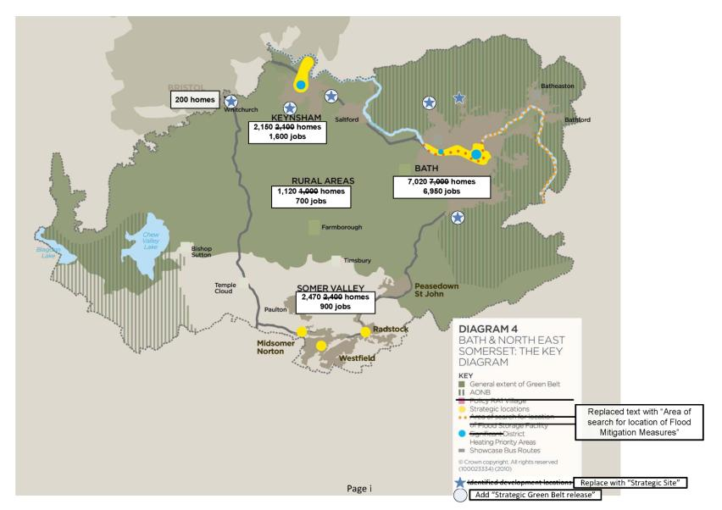

**Diagram 5 amendments**

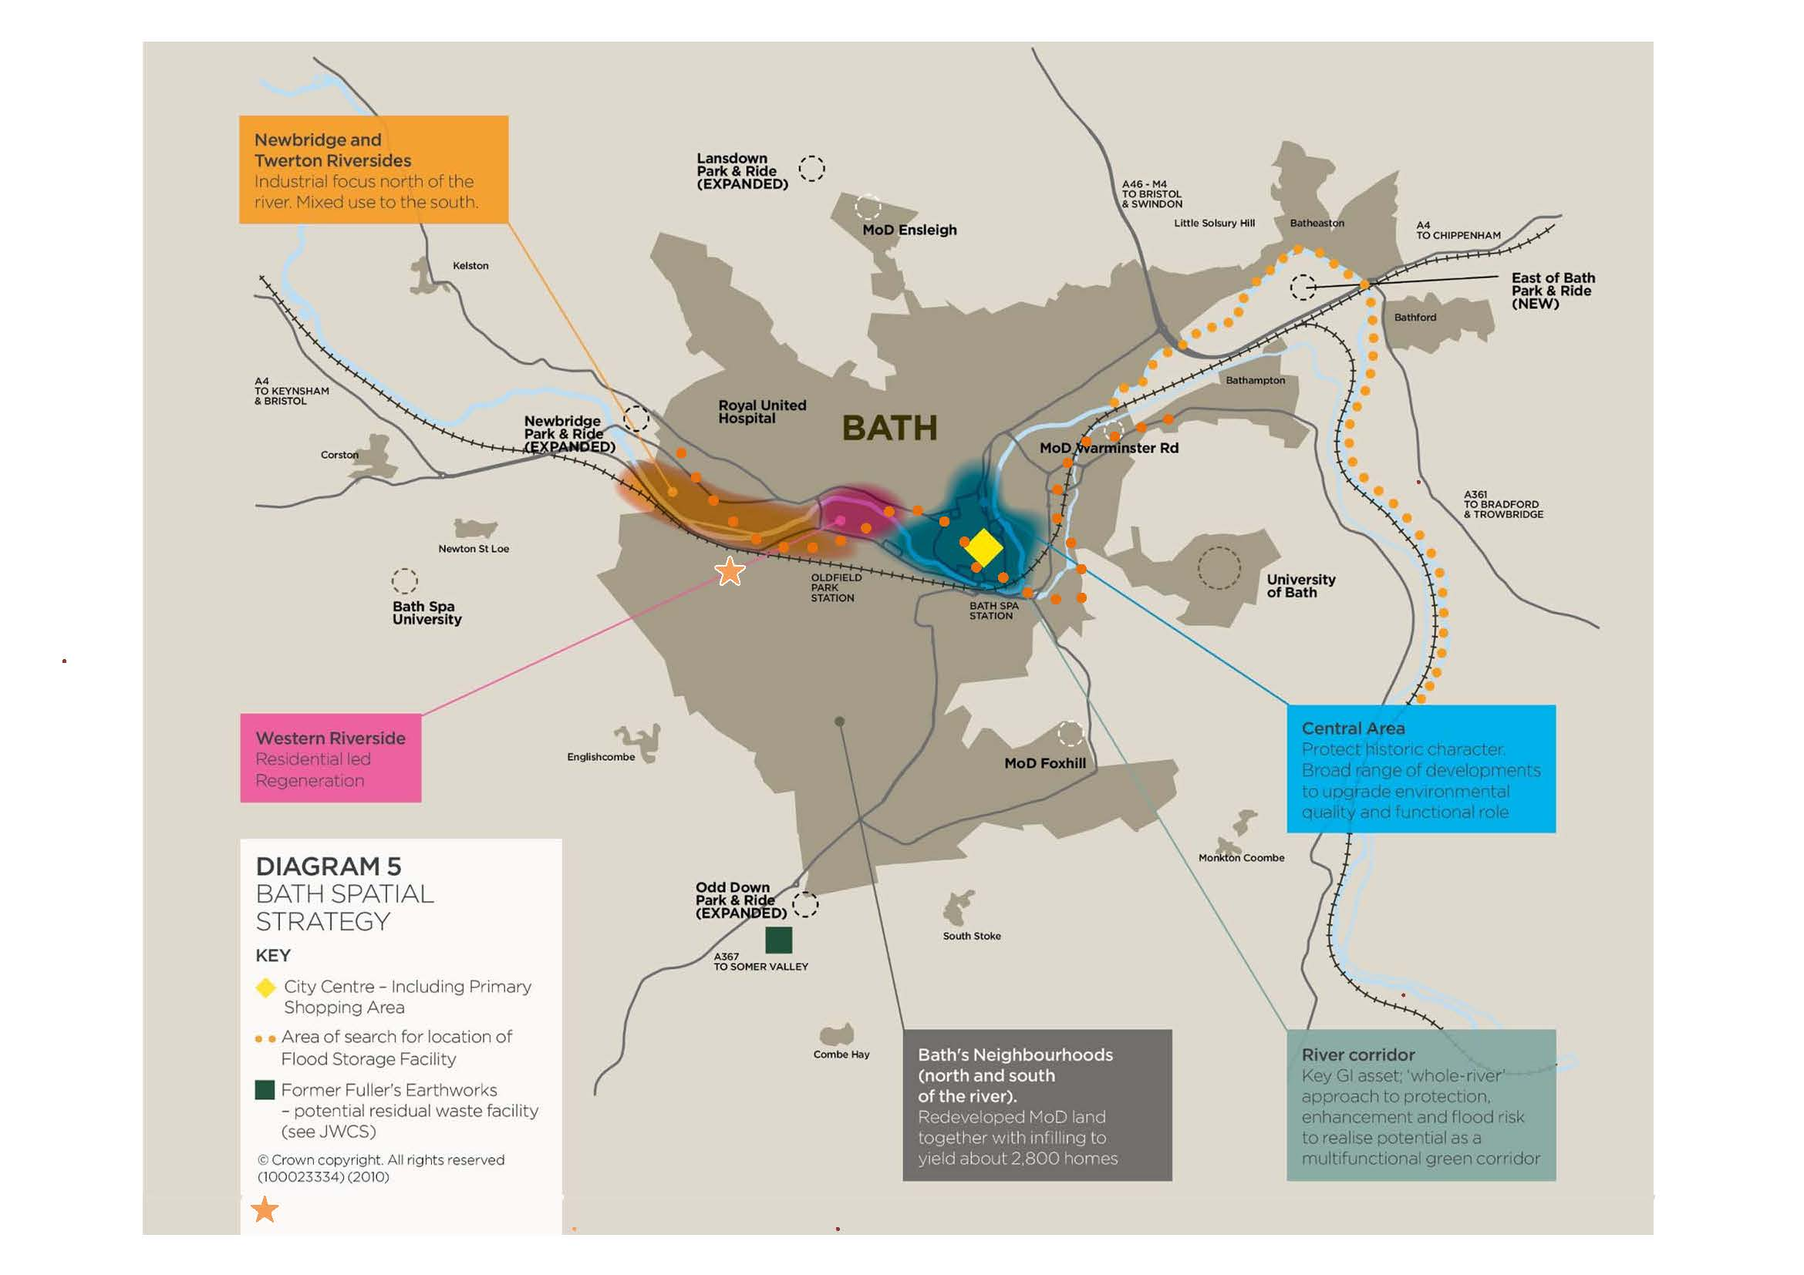

Strategic Site

Strategic Green Belt

release

Twerton Park

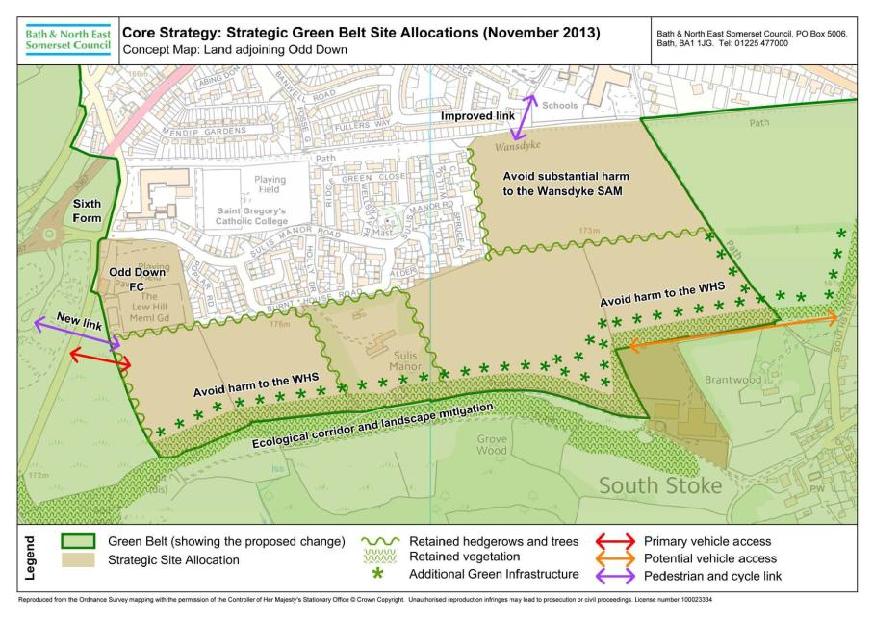

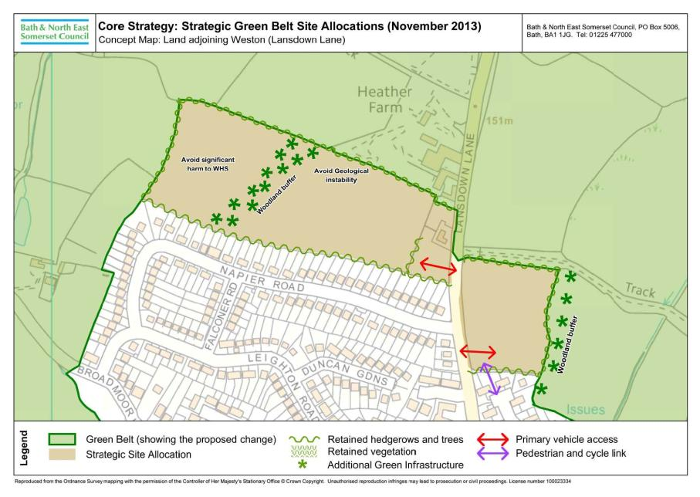

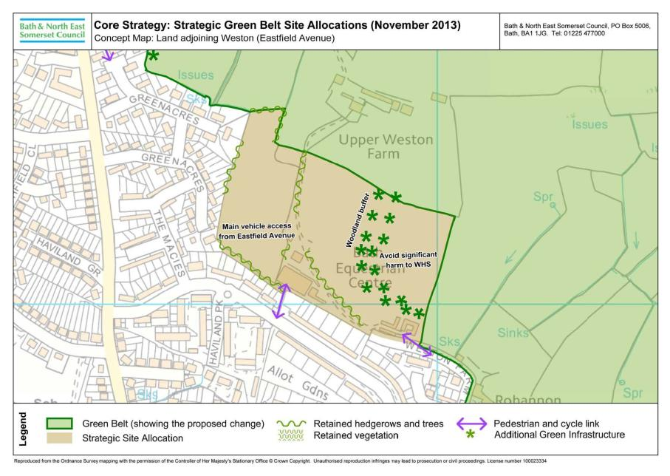

**Diagram 12 amendments**

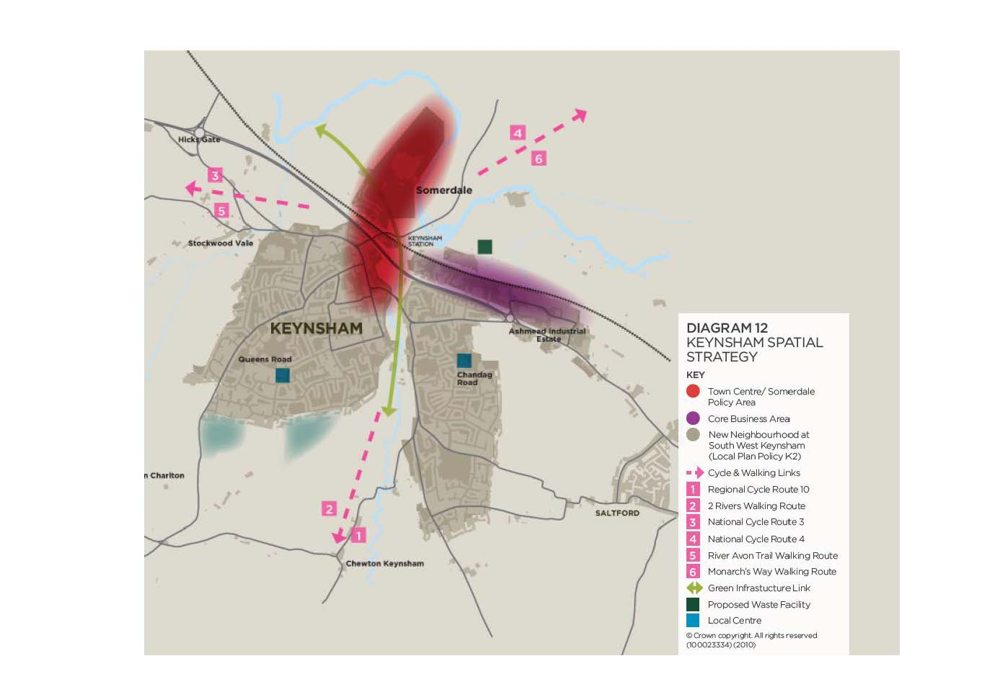

Strategic Site

S Strategic Green Belt release

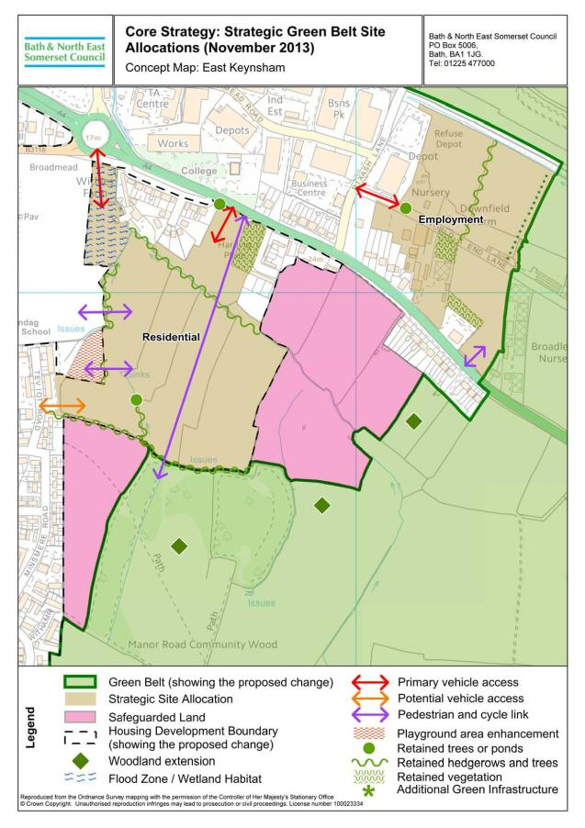

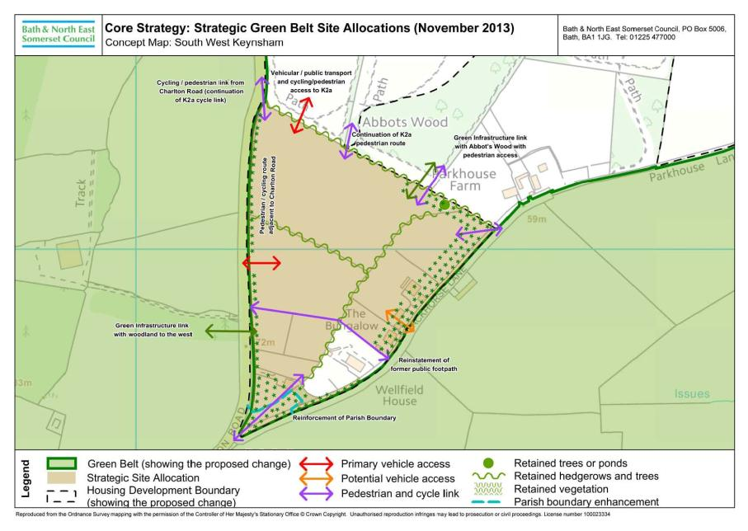

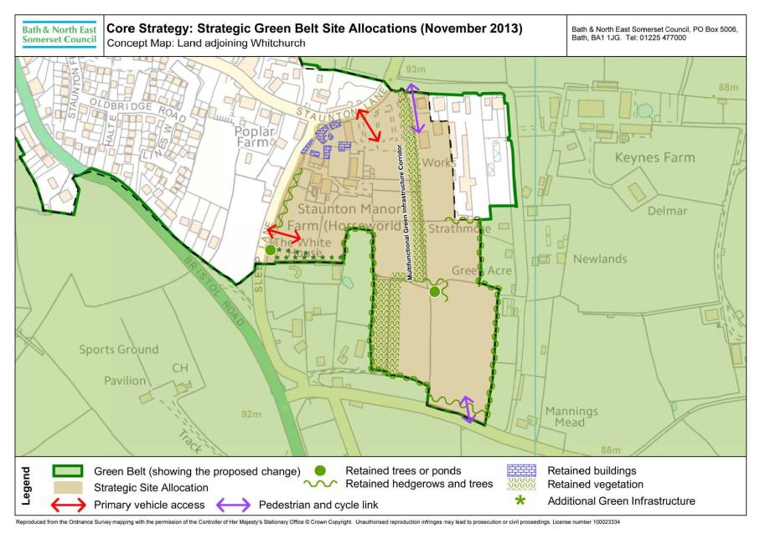

**Proposed amendments to the Policies Map**

|  |  |  |
| --- | --- | --- |
| **Change Ref** | **Proposed amendment** | **Page** |
| **CSA24** | **Amend the Policies Map to show the boundary of the strategic site allocation for Land adjoining Odd Down, Bath and the revised Green Belt boundary.** | 65 |
| **CSA28** | **Amend the Policies Map to show the boundary of the strategic site allocation for Land adjoining Weston, Bath and the revised Green Belt boundary.** | 66 |
| **CSA36** | **Amend the Policies Map to show the boundary of the strategic site allocation for Land adjoining East Keynsham and the revised Green Belt boundary.** | 67 |
| **CSA39** | **Amend the Policies Map to show the boundary of the strategic site allocation for Land adjoining South West Keynsham and the revised Green Belt boundary** | 68 |
| **CSA47** | **Amend the Policies Map to show the boundary of the strategic site allocation for Land at Whitchurch and the revised Green Belt boundary** | 69 |

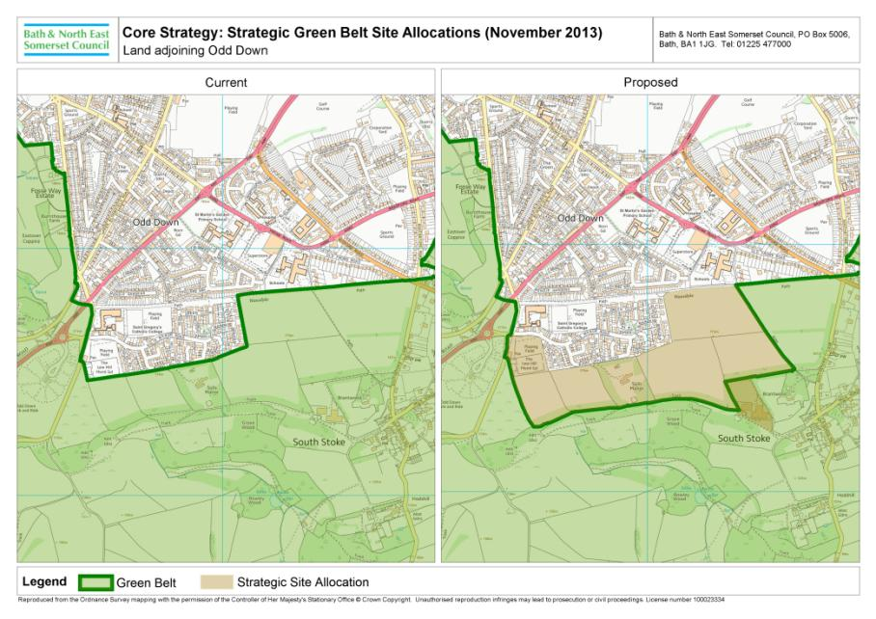

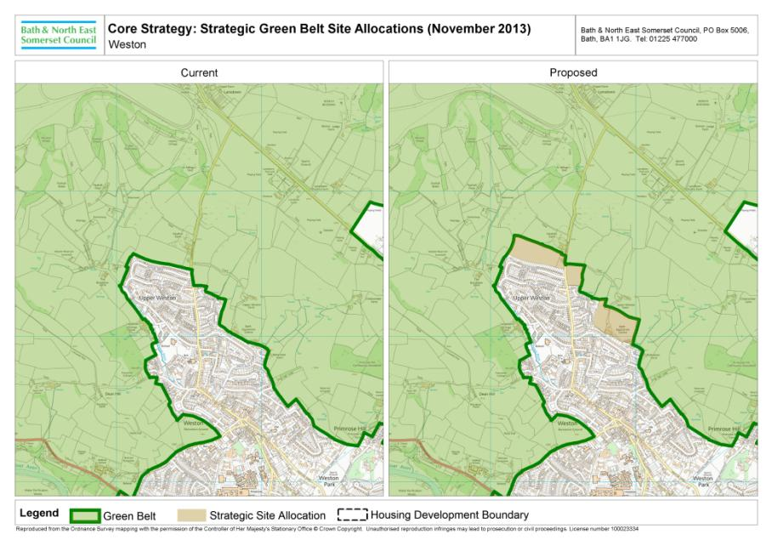

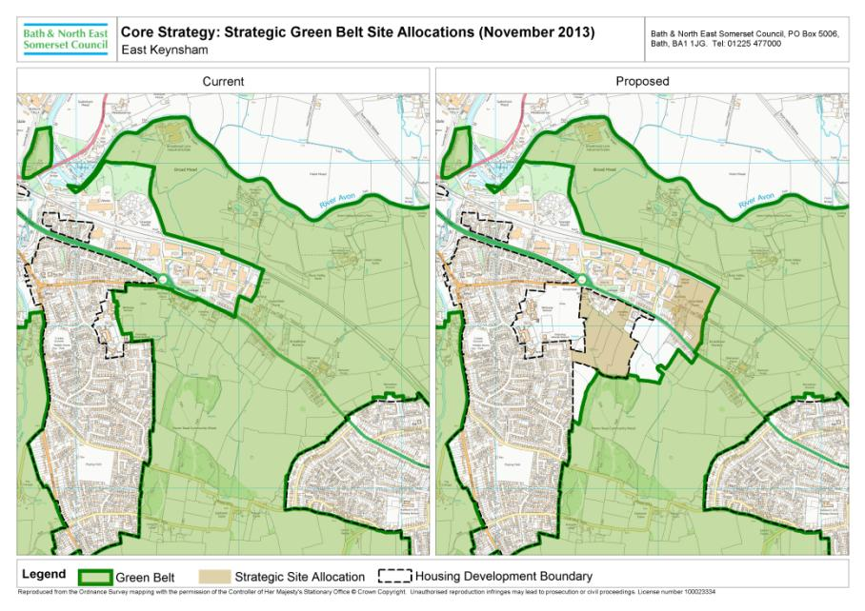

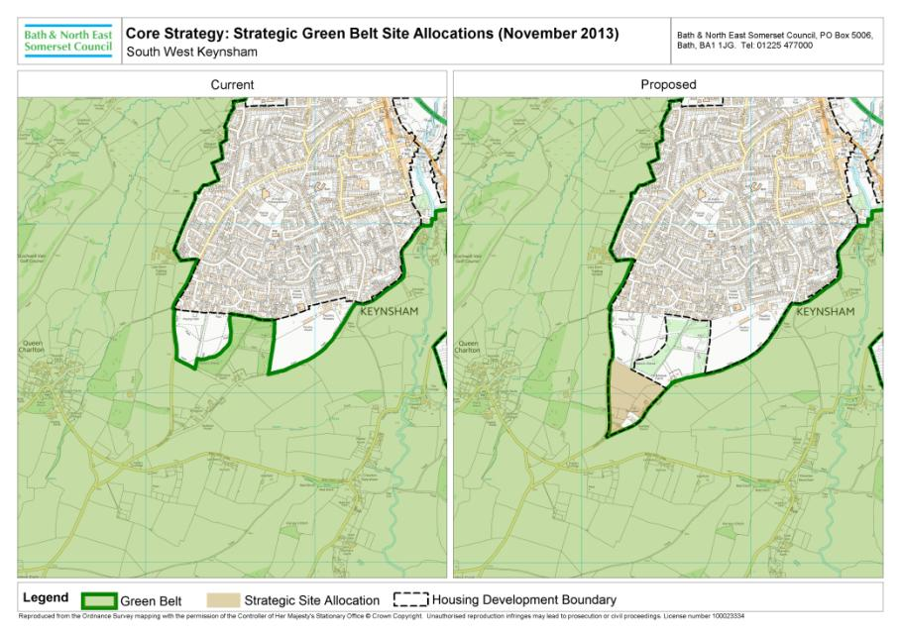

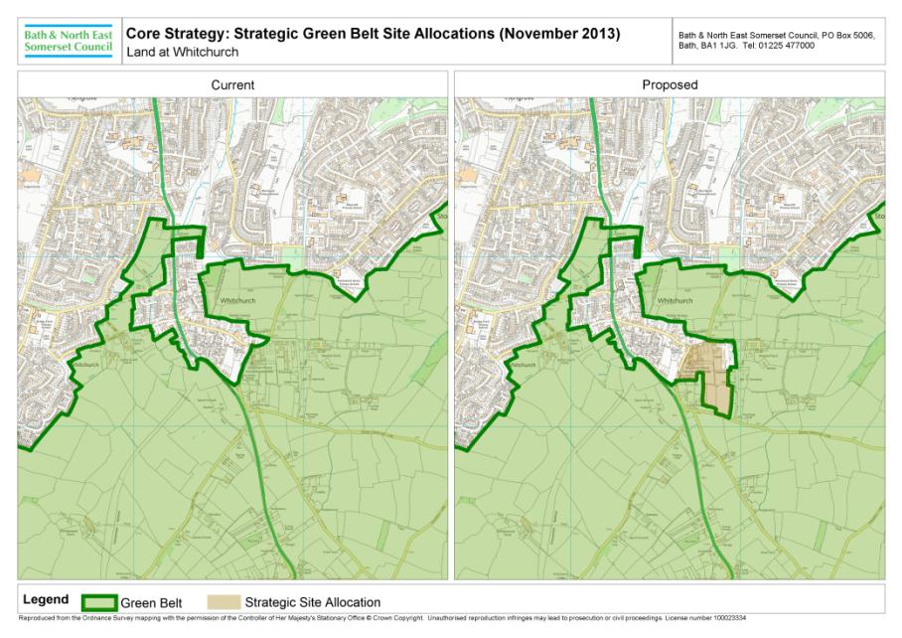

**Alternative Strategic Site Allocations considered**

|  |  |  |
| --- | --- | --- |
| **Change Ref** | **Location** | **Page** |
| **BT1** | Land adjoining Odd Down, Bath (larger option) | 71 |
| **BT2** | Land adjoining Odd Down, Bath (smaller option) | 72 |
| **KM1** | Land adjoining East Keynsham (North of railway line) | 73 |
| **KM2** | Land adjoining South West Keynsham (South of railway Line) | 74 |
| **KM2** | Land adjoining South West Keynsham (including land at Lays Farm) | 75 |
| **WH1** | Land at Whitchurch, Orchard Park | 76 |
| **WH2** | Land at Whitchurch, Horseworld | 76 |

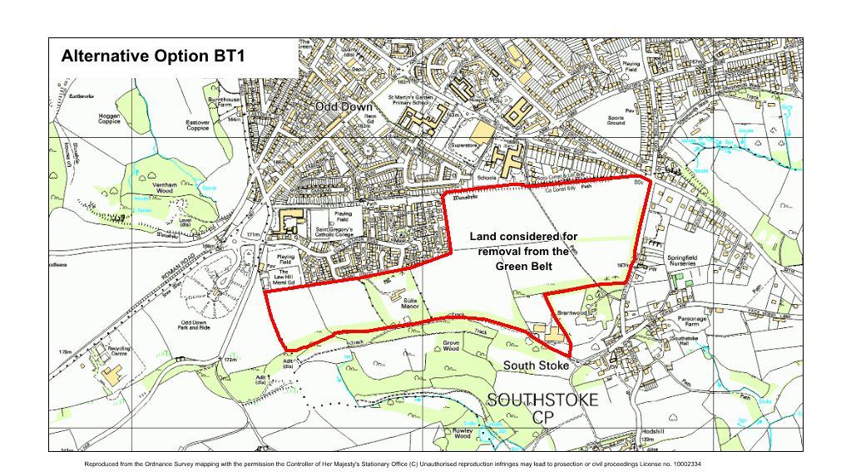

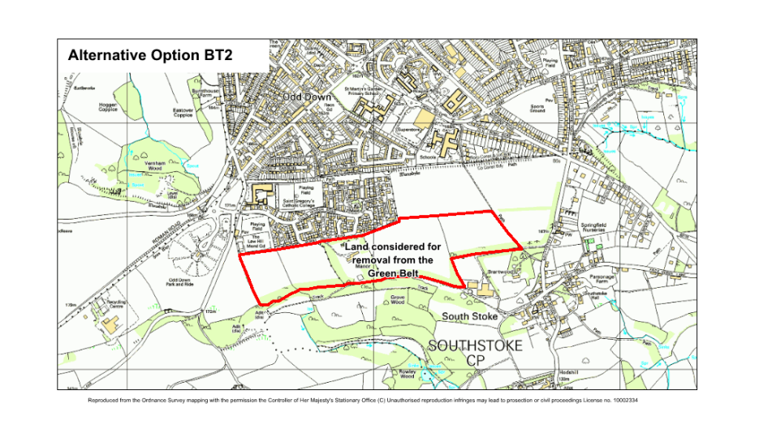

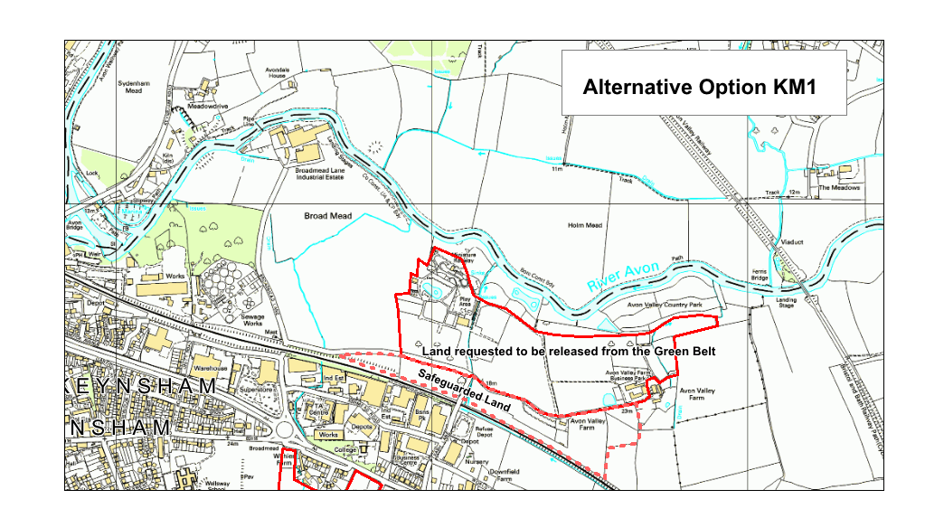

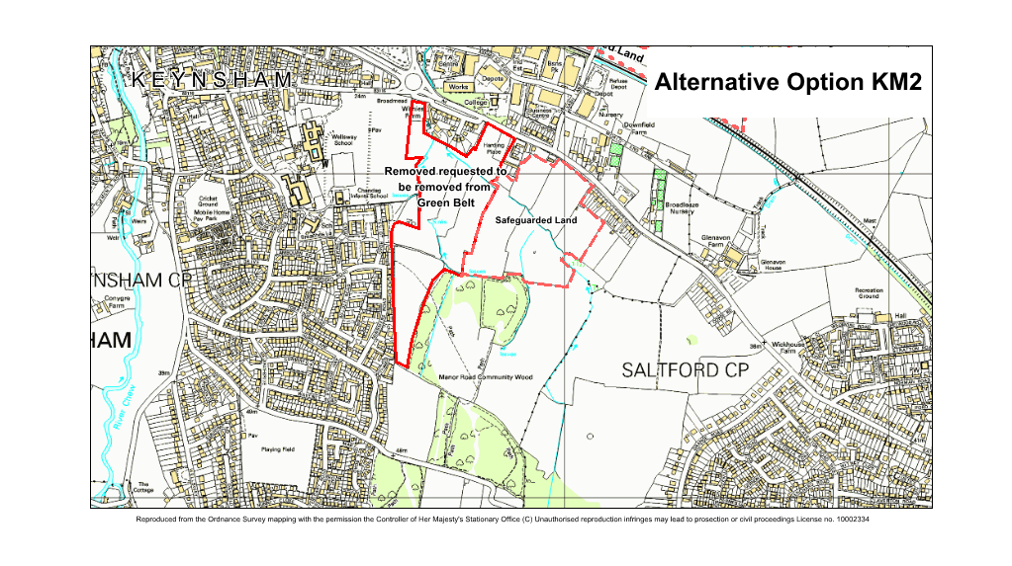

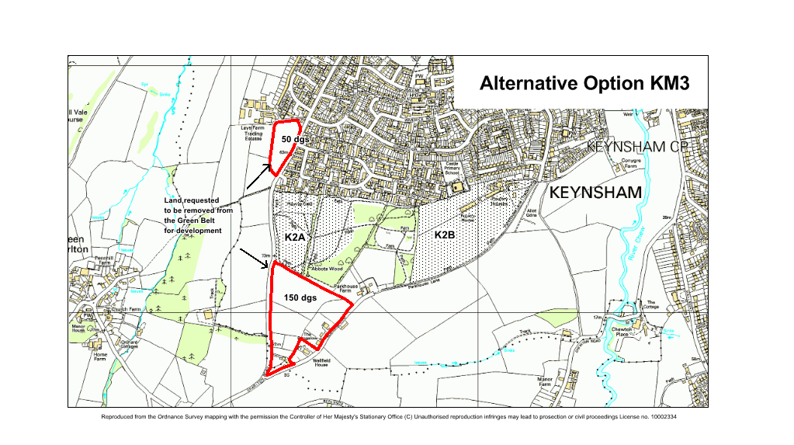

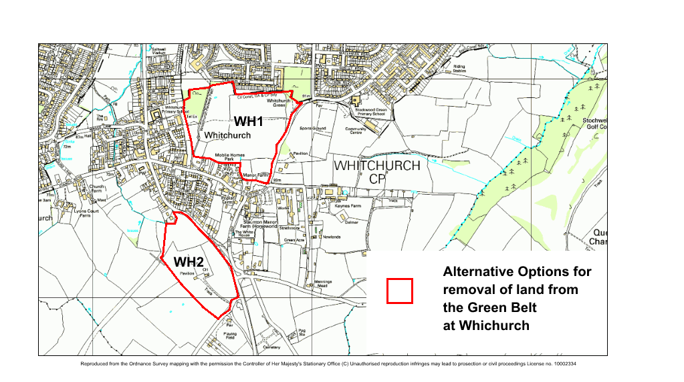

1. ‘Policies Map’ was previously known as the ‘Proposals Map’.