Retention of part-built forestry building
Frys Bottom Wood

AGM 2021 103t
Design & Access
Planning Statement
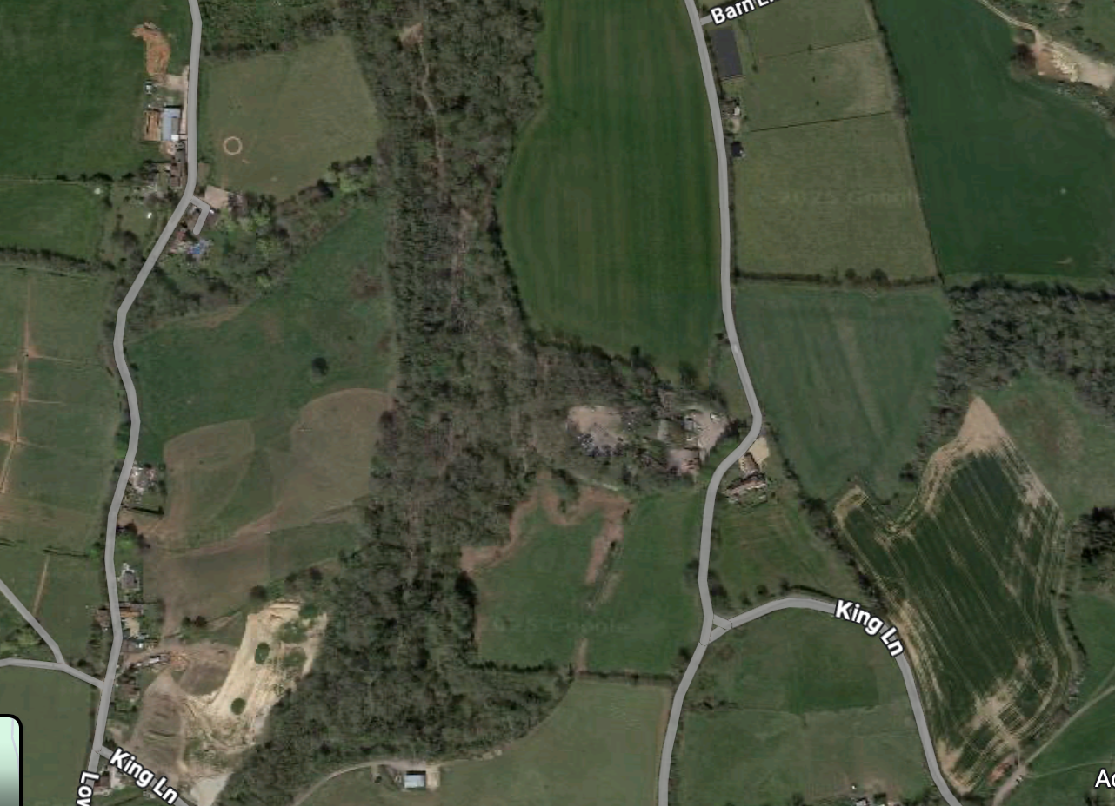

DOCUMENT CONTROL

Job No. | 2021 103t
Prepared For | Mr Willcox
Date | April 2025

 | Name | Position | Email
Prepared By | Ed Downing | Head of Planning | edward@agm-ltd.co.uk
Checked By | John White | CEO | john@agm-ltd.co.uk
Status | DRAFT

Table of Contents
1. Executive summary 1
1.1 introduction 1
Site Background 2
1.2 The Site 2
1.3 Site location 2
1.4 Local and National Designations 2
1.5 Surrounding developments 2
1.6 Relevant planning history summary 3
The Proposed Development 6
1.7 Justification: 6
1.8 Material schedule 6
Local planning policy 7
1.9 Local Planning Policy 7
National Planning Policy 9
1.10 National Planning Policy 9
Conclusion 10
1.11 Conclusion 10
Appendix a 11

Documents Submitted Alongside This Statement:
Document | Produced By
Floor plans and designs of proposed development | Jonathan Hanford
Felling License to fell growing trees | Forestry Commission
A map of the land allocated for the felling of trees at Fry’s Bottom Wood. | Forestry Commission Public Register for England
Letter of confirmation as actors of accountants for the forestry business at Fry’s Bottom. | AJM Accountants
Protected Species Survey Report | Stark Ecology

- Executive summary
  - introduction
- Arena Global Management Limited (AGM Ltd) is an independent and specialist town planning consultancy in the Bath region. AGM Ltd has prepared this Design & Access and Planning Statement on behalf of Mr S. Willcox.
- This application forms part of a retrospective full-application with regard to the proposal for a forestry building to store felled trees / logs and timber (resubmission).
- The proposed development consists of;
‘ Retention of part built forestry building’
- This statement is set out to the chapters laid out in the contents.
- This statement should be read in conjunction with the accompanying documentation listed below;
- Site Location Plan
- Existing Site Plan
- Proposed Site Plan
- Front Elevation Plan
- Side Elevation Plan
- Roof Plan
- Structural Detailing Drawing
- Site Photographs
- Both Local and National Planning Policy has been carefully considered in developing the proposal and it is understood that the proposed development is in accordance with all relevant planning policy. Therefore, it should be found permissible.

Site Background
  - The Site
- The site was purchased by Steve Willcox in 1995, with the business, known as Fry’s Bottom Timber, being set up within the year. In 1995, Mr Willcox also acquired his first Felling License and Woodland Grant Scheme from the Forestry Commission. Since then, Mr Willcox has held three Felling Licenses at Fry’s Bottom Wood.
- During Mr Willcox’s ownership of Fry’s Bottom Wood, Mr Willcox has harvested 600 trees which have been sold as logs at Fry’s Bottom Timber. Every year, accounts have been submitted to HMRC and can be used as evidence of the forestry business.
- As a result of Mr Willcox’s regeneration of the wood, Fry’s Bottom Wood has an estimated 10,000 trees which are at various stages of growth.
- Planning permission was previously granted for the building and whilst conditions were discharged and some works to the building were undertaken, it was not finished or substantially completed. New planning permission is now sought for the same building in the same use.
  - Site location
- The Application Site is located to the north east of Clutton and is accessed by King Lane, which connects the Site to the village of Clutton, as well as Chelwood and the A368 to the north.
- Construction began in December 2020 and under normal circumstances, such a development could be constructed through Prior Approval and Permitted Development rights. However, due to the fact the application site is located within 3km of an airfield, a full application has been sought.
- The application site is located within Flood Zone 1 and therefore no FRA is required.
  - Local and National Designations
- Green Belt
- Ecological Network
- Sites of Nature Conservation
  - Surrounding developments
- The application site is surrounded by a variety of existing agricultural fields and the nearby Fry’s Bottom Trails wood and camping ground. The closest residential property is approximately 80m from the application site.

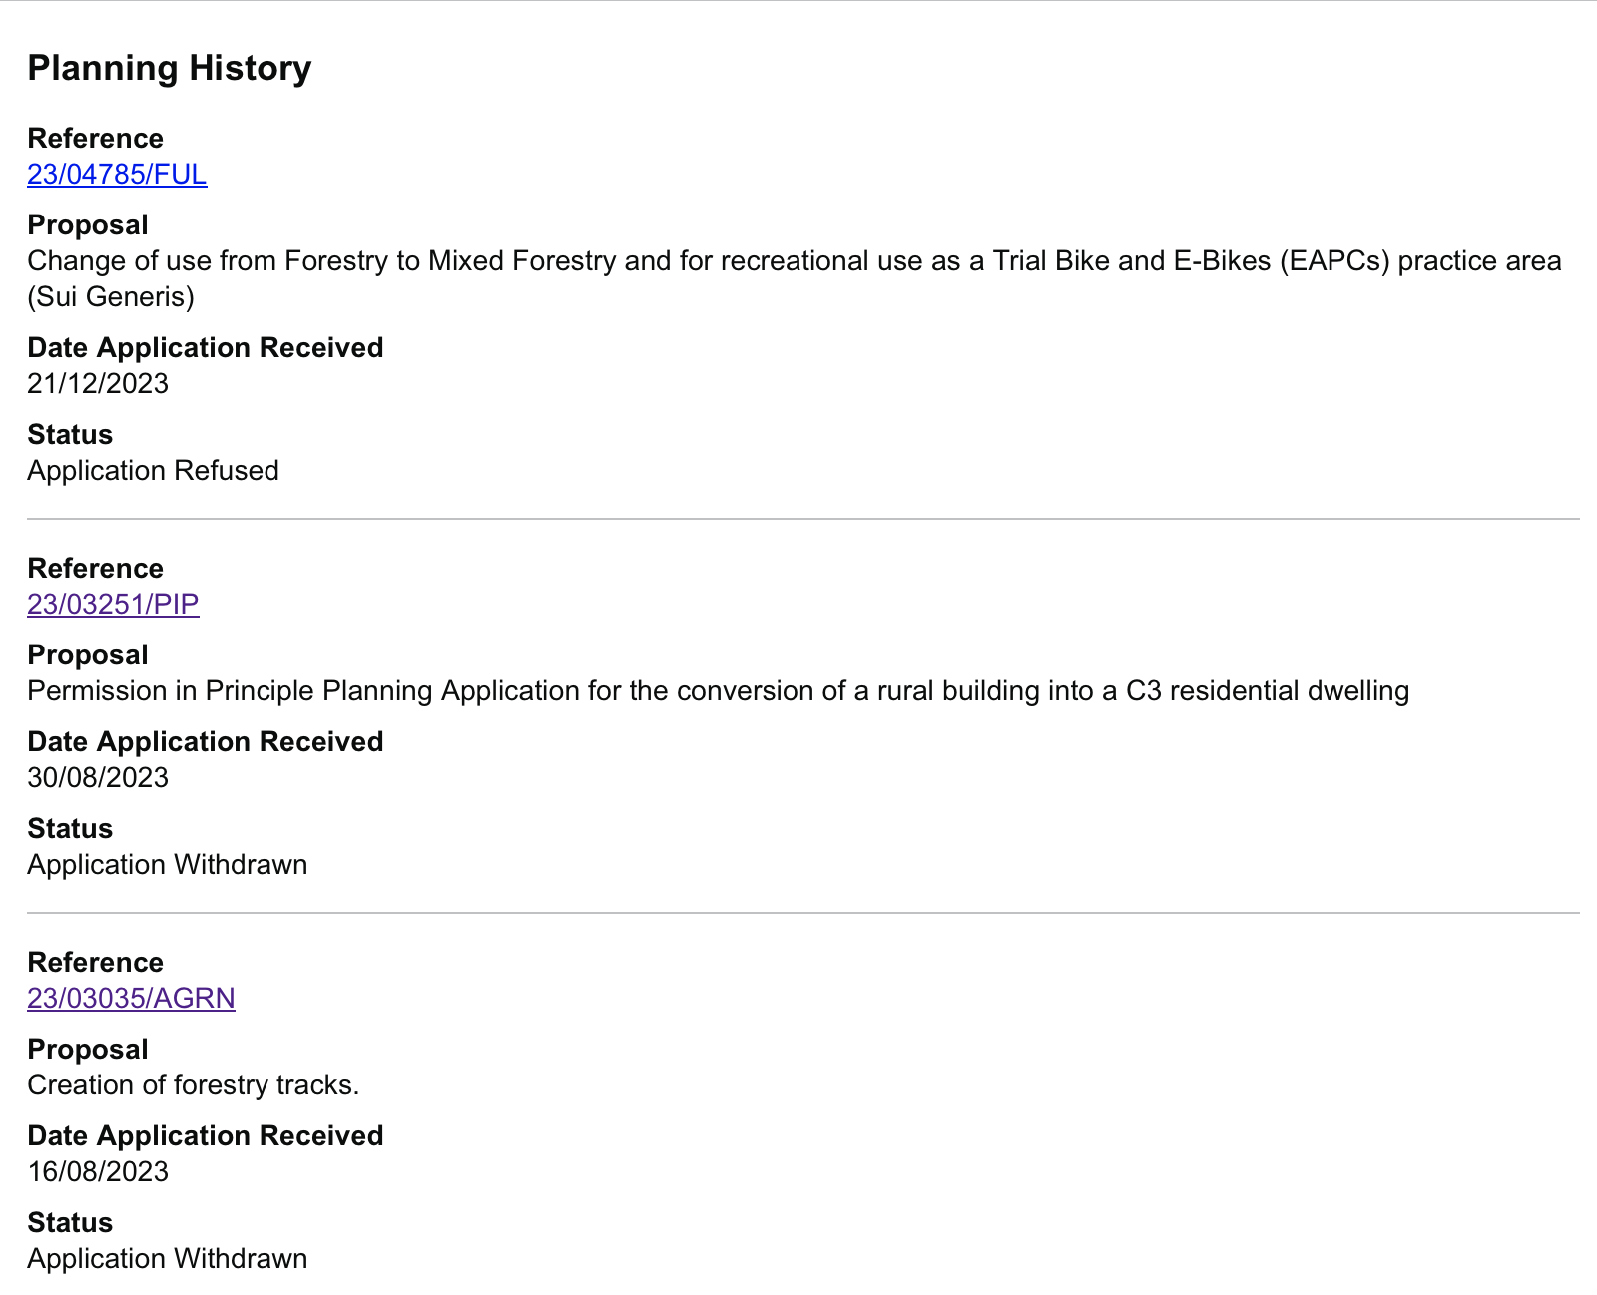
  - Relevant planning history summary

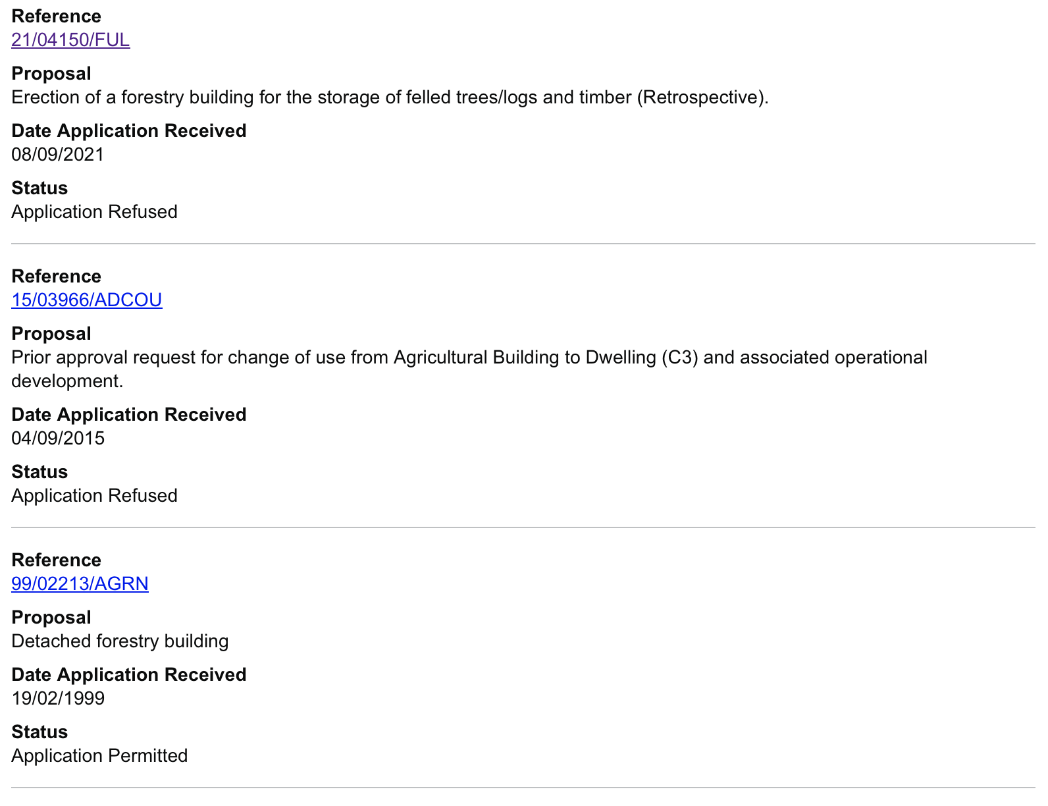

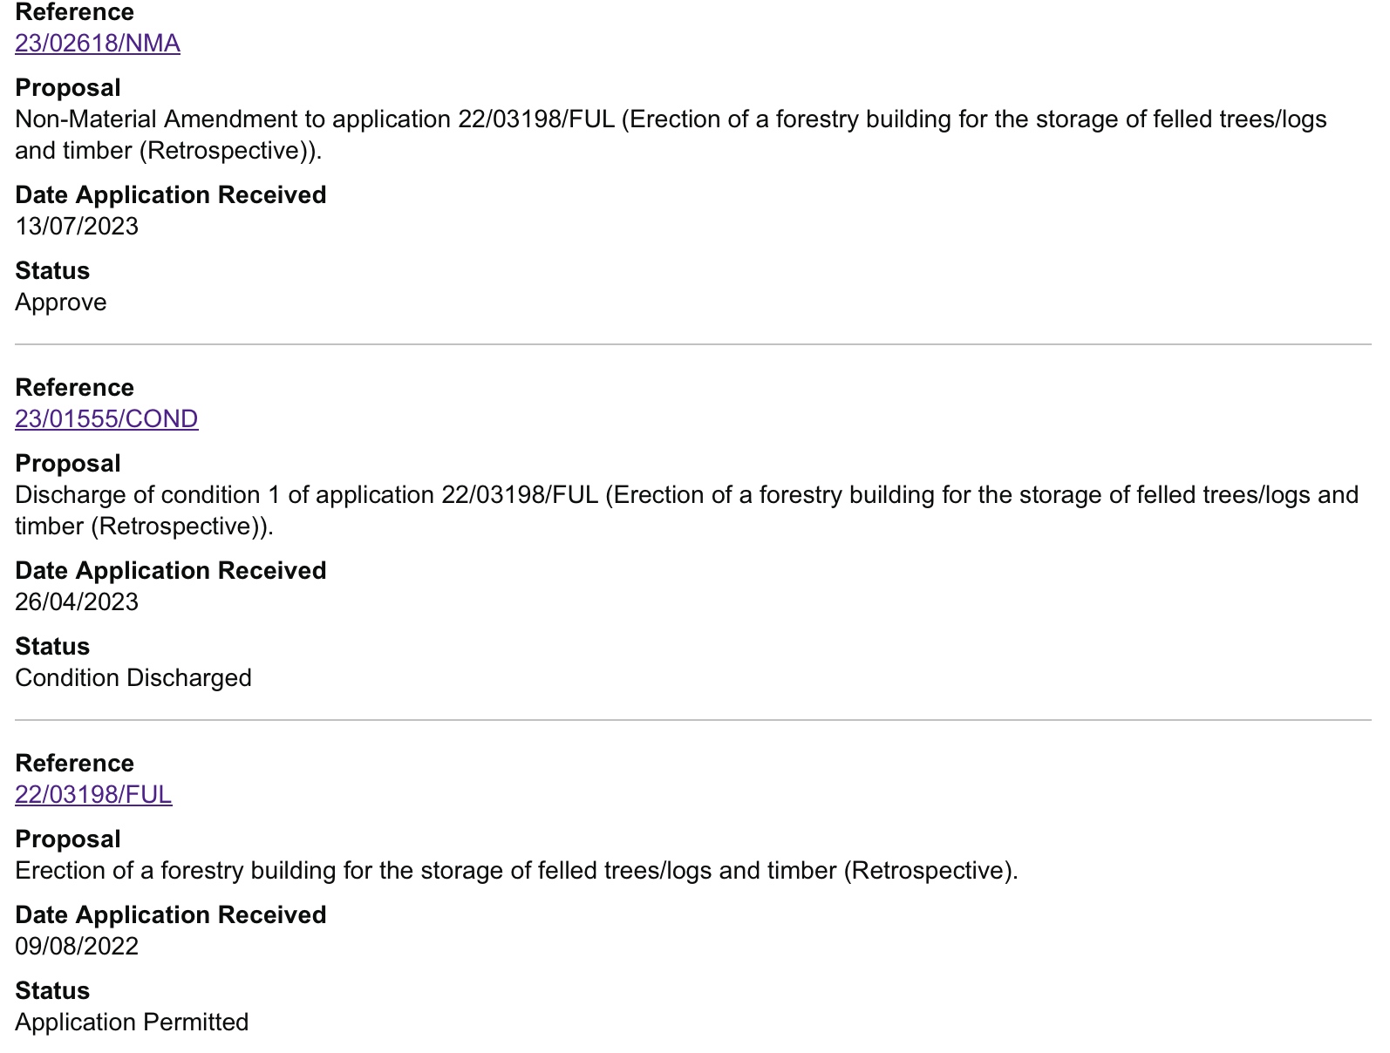

The Proposed Development
- The erection of a retrospective forestry building for the storage of felled trees/logs and timber (resubmission).
  - Justification:
- Mr. Willcox owns around 30 acres of woodland and has, over a number of years and with the necessary licenses, felled a variety of trees within his ownership for general maintenance of the woodland. Mr. Willcox also runs a small-scale forestry business and is now needing purpose-built storage to ensure that the felled logs are appropriate for custom.
- Currently, these logs are stacked in piles throughout the woodland due to a lack of appropriate storage (as the photographs demonstrate within the next section). It is now required that logs that are designated for sale must be dried to a 20% moisture content. To achieve this, the logs have to be stored inside or undercover to avoid rain cover. The forestry building will be used all year round for this purpose.
- As a result of maintenance of the wood and the felling and sale of logs at Fry’s Bottom Timber, Mr Willcox has developed a collection of essential machinery over time. To maintain the condition of the machinery and ensure their safety, Mr Willcox aims to store the machines within the proposed development, alongside felled logs. – See Appendix A Photos
- The approval of this retrospective forestry building would enable the felled trees to be dried and processed into logs. Furthermore, the forestry building would ensure that the woodland remains clear of current and future felled timber, as well as improving the quality of the timber for prospective clients.
- The forestry building is located on an existing hardstanding surface.
  - Material schedule
- The proposal has been designed in such a way to minimise its visual impact to the surrounding locality. The forestry building is constructed of structural steel and will be cladded by concrete panels (to be stained green), as well as natural stained Yorkshire boarding. Additionally, the roof is to be constructed from composite sheeting, similarly coloured green to match the side elevation. As this demonstrates, the proposed forestry building seeks to blend harmoniously into the existing woodland, adopting colours similar to the surrounding context. This resubmission now includes roller doors as per the BANES ecologist’s recommendation.
Local planning policy
  - Local Planning Policy
- The following policies from the B&NES Core Strategy (adopted July 2014) document and Placemaking Plan (adopted July 2017) and LPPU 2023.
    - Policy SD1: Presumption in favour of sustainable development
    - Policy CP8: Green Belt
    - Policy D2: Local Character and Distinctiveness
    - Policy NE2: Conserving and Enhancing the Landscape and Landscape Character
    - Policy NE3: Sites, Species and Habitats
    - Policy NE6: Trees and Woodland Conservation
- Policy SD1: Presumption in Favour of Sustainable Development - This policy states that “When considering development proposals, the Council will take a positive approach that reflects the presumption in favour of sustainable development contained in the National Planning Policy Framework”. The proposed development conforms to this objective, supporting the economic development within the rural economy.
- Policy CP8: Green Belt - This policy states that “The openness of the Green Belt will be protected from inappropriate development in accordance with national planning policy”. Considering Paragraph 149(a) of the NPPF states that buildings for agriculture and forestry are exceptions to Green Belt policy, the proposed development should be found acceptable.
- Policy D2: Local Character and Distinctiveness - This policy states that "Development proposals will be supported where they contribute positively to and do not harm local character and distinctiveness”. The proposed development is situated within an agricultural setting and would respond positively to the existing site context. The forestry building is to be finished with concrete panels (stained green) as well as natural stained Yorkshire boarding. Additionally, the roof is to be constructed from composite sheeting, also coloured green. As this demonstrates, the proposed forestry building seeks to blend harmoniously into the existing woodland, adopting colours similar to the surrounding context, positively reflecting the local landscape.
- Policy NE2: Conserving and Enhancing the Landscape and Landscape Character - The proposed development will continue to conserve the local landscape, having an associated use within forestry. Without the felling of trees infected by Ash Dieback, the woodland will not be able to be maintained and will consequently suffer as the disease spreads. This will consequently impact the whole landscape surrounding Fry’s Bottom Wood. Additionally, the proposed development is well screened and not visible from outside the site.
- Policy NE3: Sites, Species and Habitats - This policy sets out the Council’s strategy for the protection and conservation of sites, species and habitats. The proposed development would not have an impact to the Nature Conservation site and Ecological Network and therefore should be found permissible.
- Policy NE6: Trees and Woodland Conservation - This policy states that “Development will only be permitted where “it seeks to avoid any adverse impact on trees and woodlands of wildlife, landscape, historic, amenity, productive or cultural value”. The proposed development would remove the current felled timber from the woodland space and ensure that future felled trees can be stored in a way that does not interrupt the woodland floor. Furthermore, as Ash Dieback is impacting all Ash Trees throughout the UK, the maintenance and felling of these are crucial in maintaining the existing forest.

National Planning Policy
  - National Planning Policy
- The forestry building is located on an existing hardstanding surface.
- Legislation and the National Planning Policy Framework (NPPF) require that planning applications are to be decided in accordance with the statutory development plan for an area unless other material planning considerations indicate otherwise. As a matter of policy, the Government has stated in the NPPF (Paragraph 11) that this means approving development proposals that accord with the Development Plan without delay.
- The National Planning Policy Framework (NPPF 2024)) sets out the Government’s planning policies for England and how these are expected to be applied. The NPPF must be taken into account in the preparation of Local Plans and is a material consideration in planning decisions.
    - The following Chapters have been deemed relevant to this application:
    - Part 2: Achieving Sustainable Development
    - Part 6: Building a strong, competitive economy
    - Part 13: Protecting Green Belt Land
    - Part 15: Conserving and Enhancing the Natural Environment
- Part 2: Achieving Sustainable Development - Paragraph 11 states that “Plans and decisions should apply a presumption in favour of sustainable development”. Paragraph 8, which precedes this point, considers that sustainable development has been accomplished when three overarching objectives have been achieved. These objectives are: economic, social, and environmental in principle. Paragraph 9 follows, stating that “Planning policies and decisions should play an active role in guiding development”, taking the local circumstances into account. The proposed development conforms to this objective through its use of sustainable materials within construction and supporting the rural economy.
- Part 6: Building a Strong, Competitive Economy - Paragraph 84(a) states that “Planning policies and decisions should enable the sustainable growth and expansion of all types of business in rural areas; both through conversion of existing buildings and well-designed new buildings”. The proposed development conforms to this objective, allowing an existing rural business to expand and grow their services in the local area.
- Part 13: Protecting Green Belt Land - Paragraph 137 states that “the fundamental aim of Green Belt policy is to prevent urban sprawl by keeping land permanently open; the essential characteristics of Green Belts are their openness and their permanence”. However, Paragraph 149(a) states that buildings for agriculture and forestry are exceptions within this Policy. Therefore, the proposals should be found permissible. The proposed development is also designed to blend with its surroundings, and it is not visible from outside the site, due to the high coverage of surrounding vegetation.

Conclusion
  - Conclusion
- The forestry building is located on an existing hardstanding surface.
- This application forms part of a retrospective full application to support the erection of a forestry building to store felled trees / logs and timber at Frys Bottom, Clutton (resubmission).
- The proposed development consists of;
• The erection of a retrospective forestry building for the storage or felled trees / logs and timber (resubmission).
- Supporting documents have provided evidence that the proposed development is required to assist the forestry business at Fry’s Bottom Wood and therefore continue the business. The land at the application site has been reviewed to ensure that it is of sound nature and quality to be built on, and ecological surveys have been undertaken to ensure that the proposed development poses no harm to the surrounding area and supports the habitats within it. The proposed forestry building is designed to be well integrated and blend harmoniously into its surroundings, limiting its visual impact on the landscape.
- As demonstrated within this statement, any impacts arising from the proposed development have been suitably mitigated through the design and provision of specific measures identified within the supporting material.
- The proposed development is therefore in accordance with the National Planning Policy and the adopted Local Development Plan and should be granted permission.
Appendix a
